Colorado Has Pride
By Aiden McVay
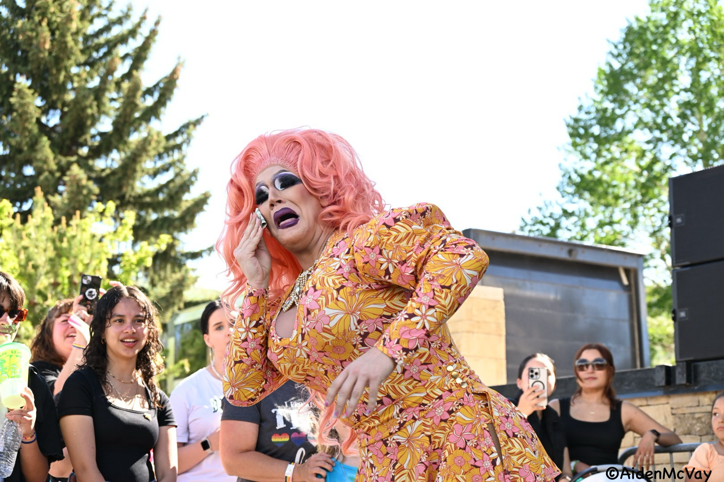Zackarina Jenny-hoe Mountain Pride, June 1, 2024. Avon.
Pride is more than just a word. It’s not just a celebration, it is an act of resistance. In today’s world, being an LGBTQ+ person is dangerous. With mass shootings, transgender people being a target, and homophobia still being rampant, it is truly brave. Pride isn’t just a day, it is state of being so desperately needed. Although we’ve come a long way from the Stonewall Riots, much more work is needed. Until there is no longer a need to be in the closet, until people feel safe being themselves, and until we are not afraid to be killed for who we love or who we are, Pride needs to be celebrated, acknowledged, and accepted.
Many Prides this year did it upright. Mountain Pride in Avon, Colorado for one. They had some help from Maddy Partridge, somebody who not only helped me get an accessible parking space but was one of the organizers in this fantastic pride. Orlando Oritz helped draw the crowd by booking the fantastic MC’s, drag
performers and headliners including Zackarina Jenny-hoe, Raquelle C Shelle, and Ramona Chingona.
Ouray Pride hit it hard with their Drag performances as well with Aria Petty One, MixTrixs and out of towner Maxine LaQueen. The crowd went absolutely wild for MixTrixs with their high kicks and offering flowers to the audience. One of Ouray Pride’s organizers and photographers, Taylor Nowak, took amazing pictures of the crowd and performers.
This year, for the first time, Pride came to the small town of Montrose.
Organizer of Montrose Pride, Evelyn Greenman-Baird said, “(Pride) is just a loud and proud show of community and individuality…a vibrant expression of who we are.” Evi continues, “A lot of people here oftentimes don’t feel safe or comfortable existing authentically every day, but this is a space where they can do that if it’s just one day a year, I love it.”
Surprisingly, for this conservative town, they were met with very little backlash. Many local vendors supported them including $1000 donation by Community Spirit Church for the amphitheater rental. Despite a few haters, and local businesses not wanting to support or donate because they do not agree, Montrose pride had a headcount of over 700 people in attendance.
Probably in part to the amazing headliners the Van Dykes, including Xavi Van Dyke, the founder of Delta pride, who was also the MC for this event.
Between the vendors, the amazing performances, and the inclusion, Montrose pride embodied what a pride celebration should be.

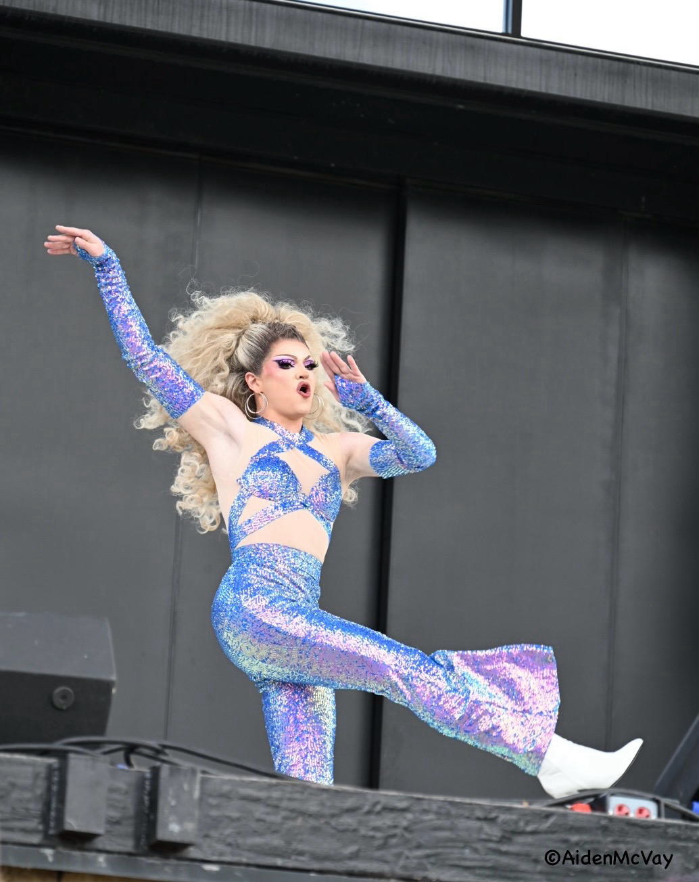
Roquelle C Shelle Mountain Pride, June 1, 2024
Avon, CO.

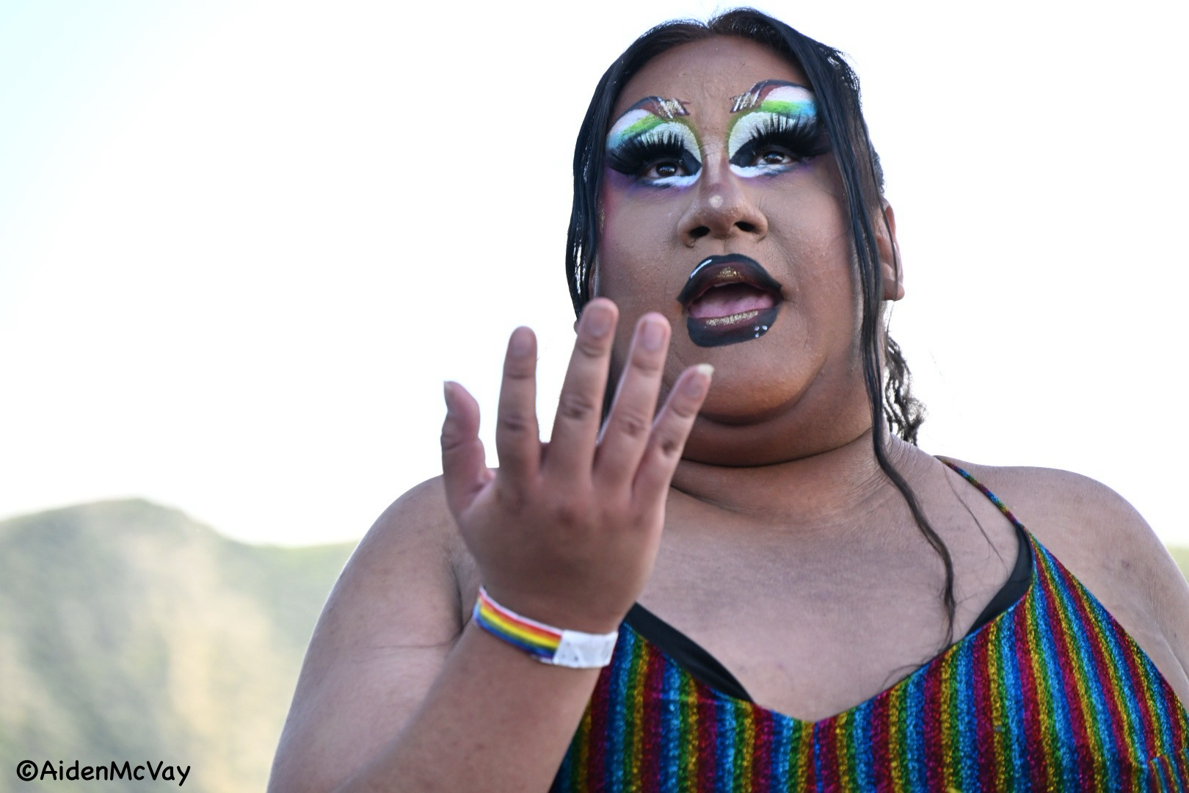
The Petty Patty Mountain Pride, June 1, 2024

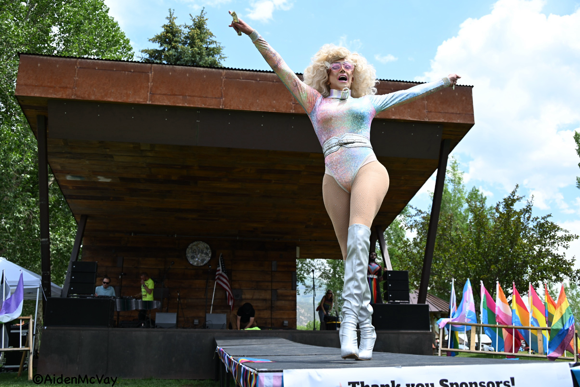
Aria Petty One Ouray Pride June 15, 2024

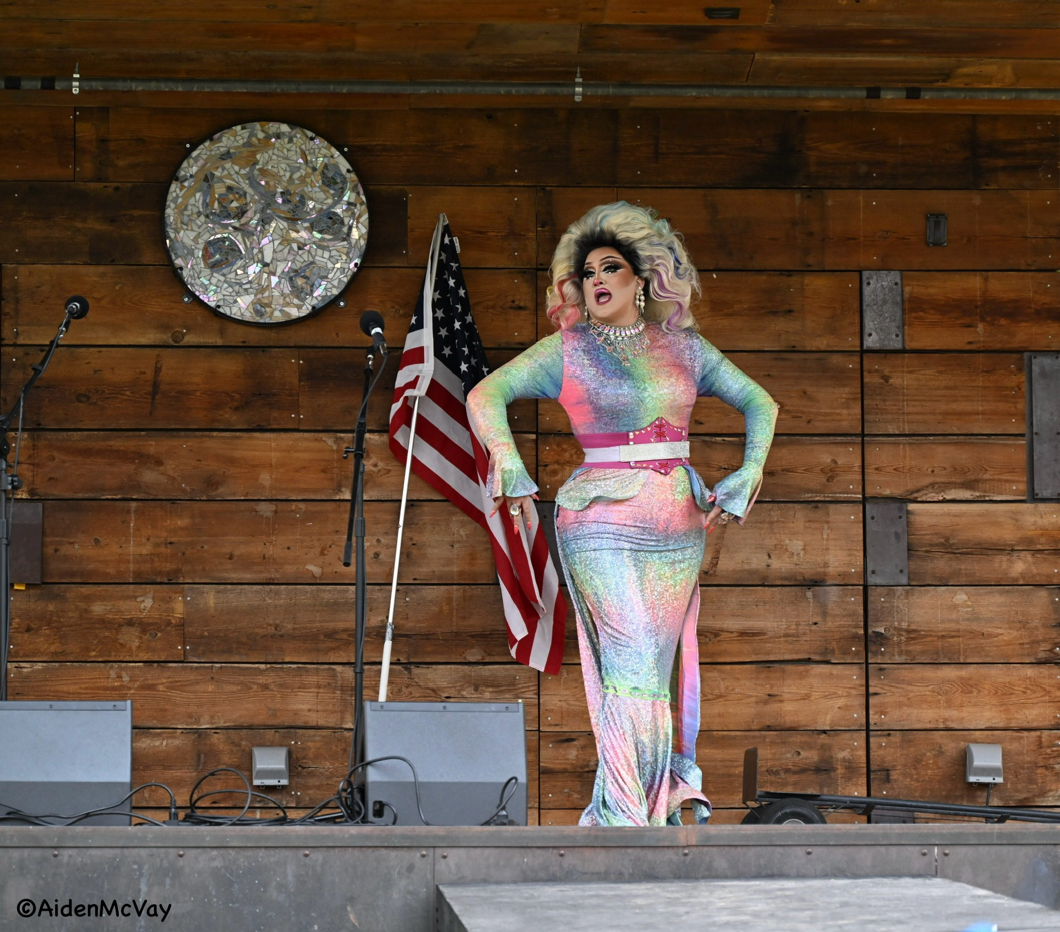
Maxine LaQueen Ouray Pride June 15, 2024
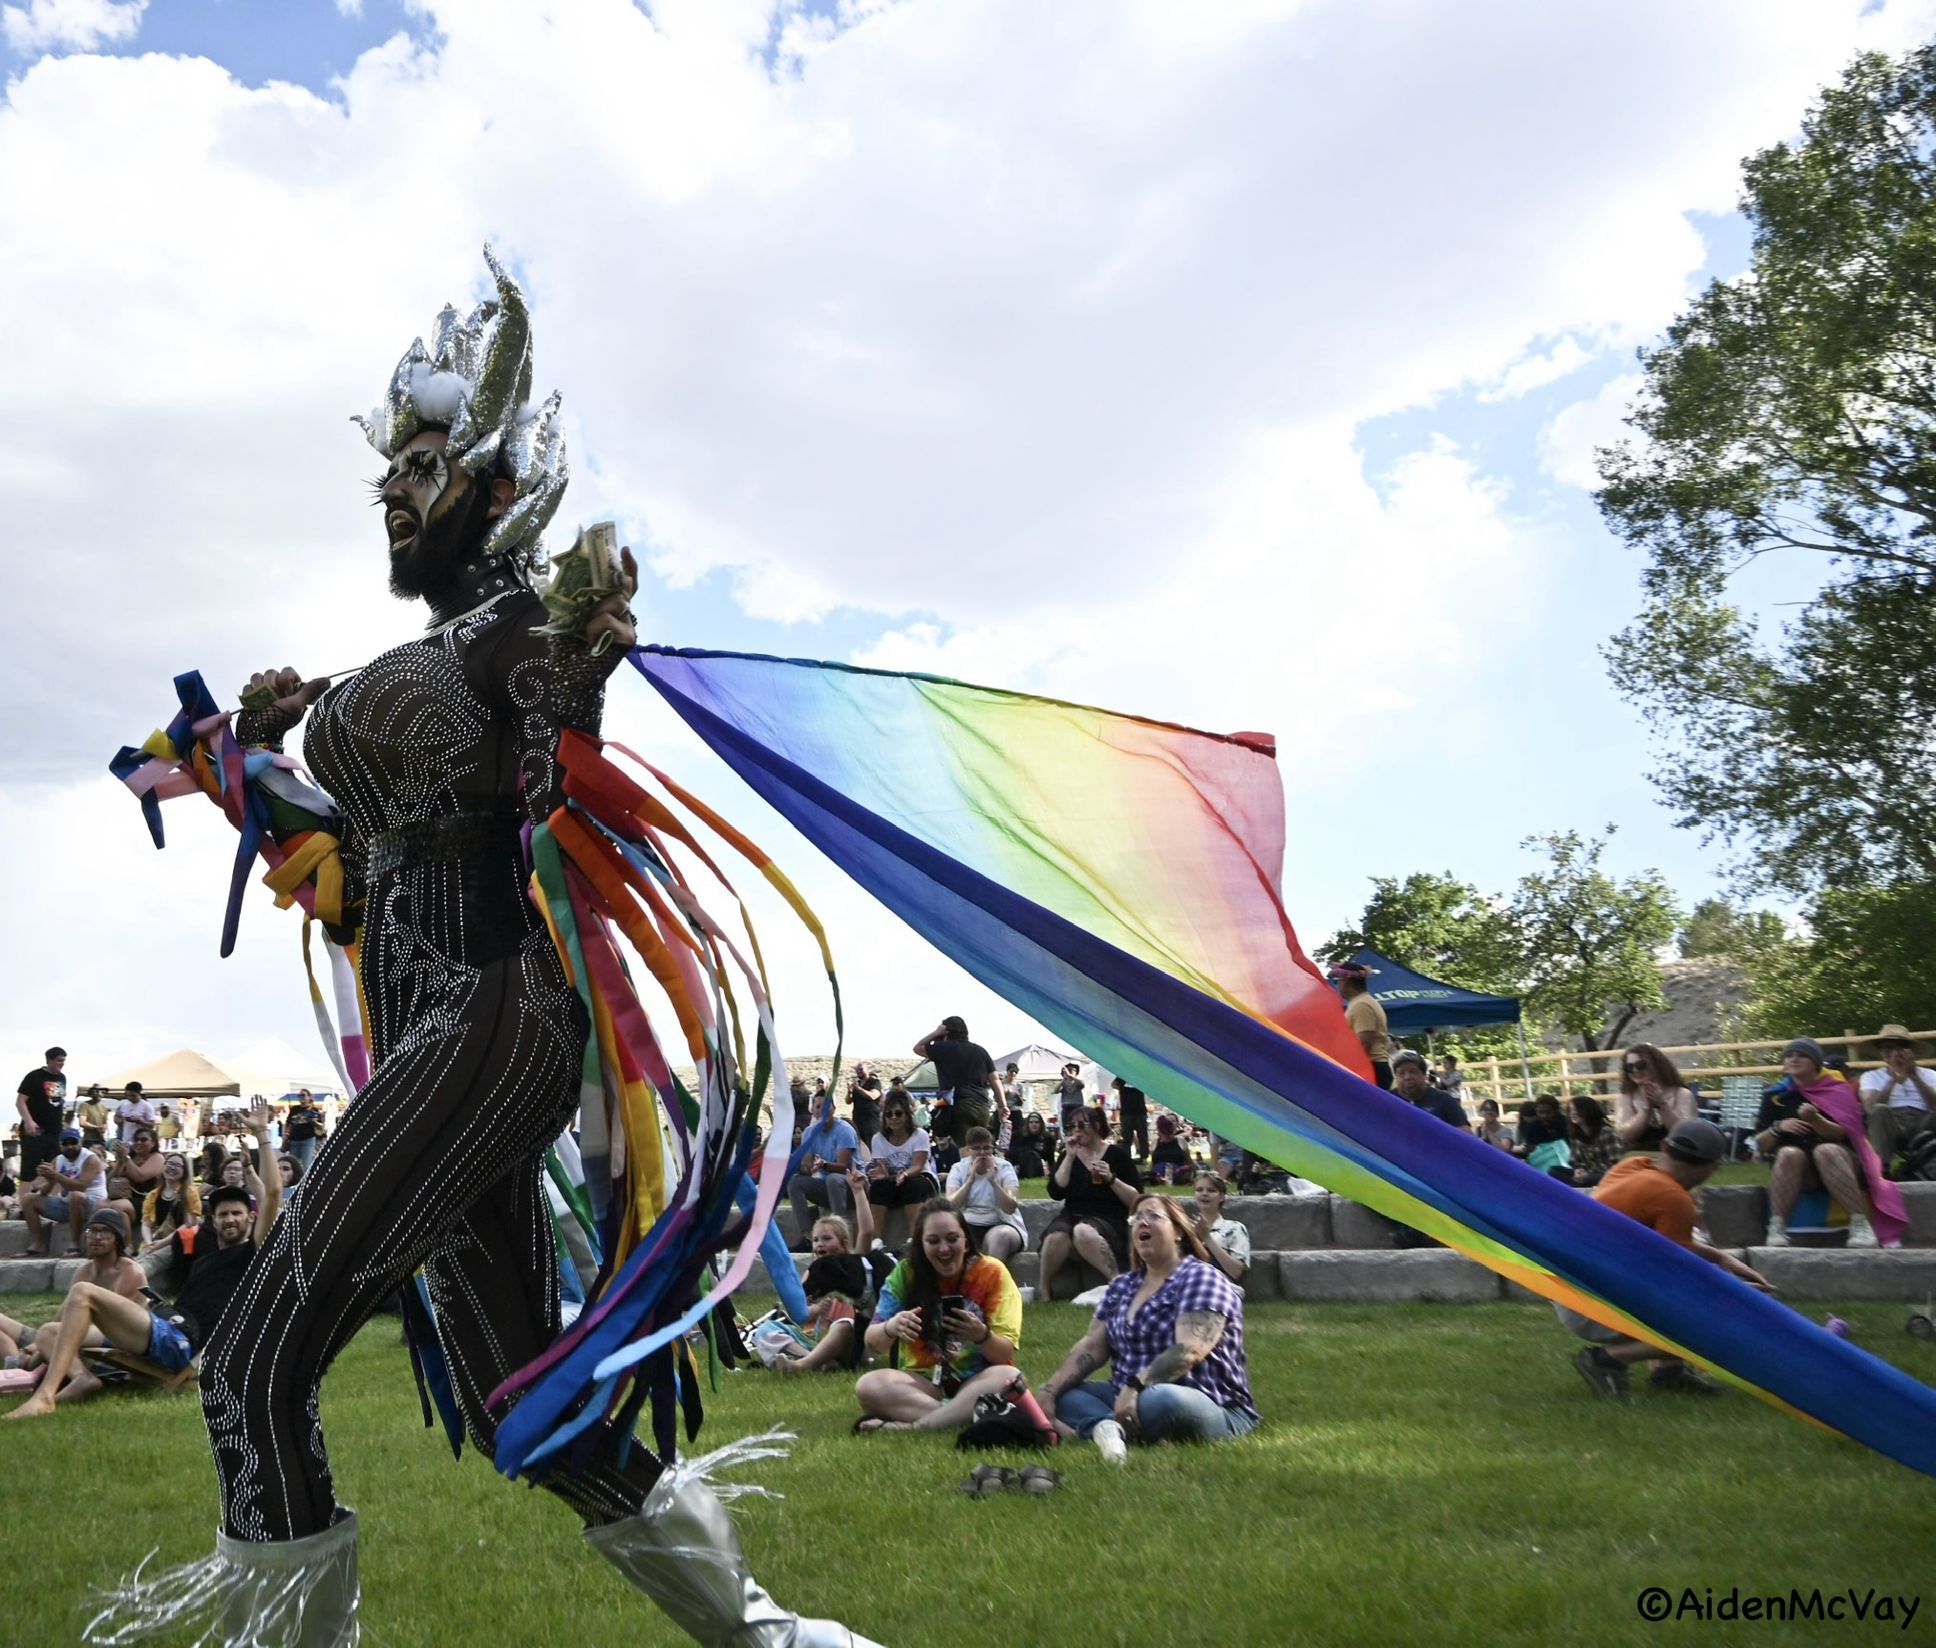
MixTrix Montrose Pride June 8, 2024
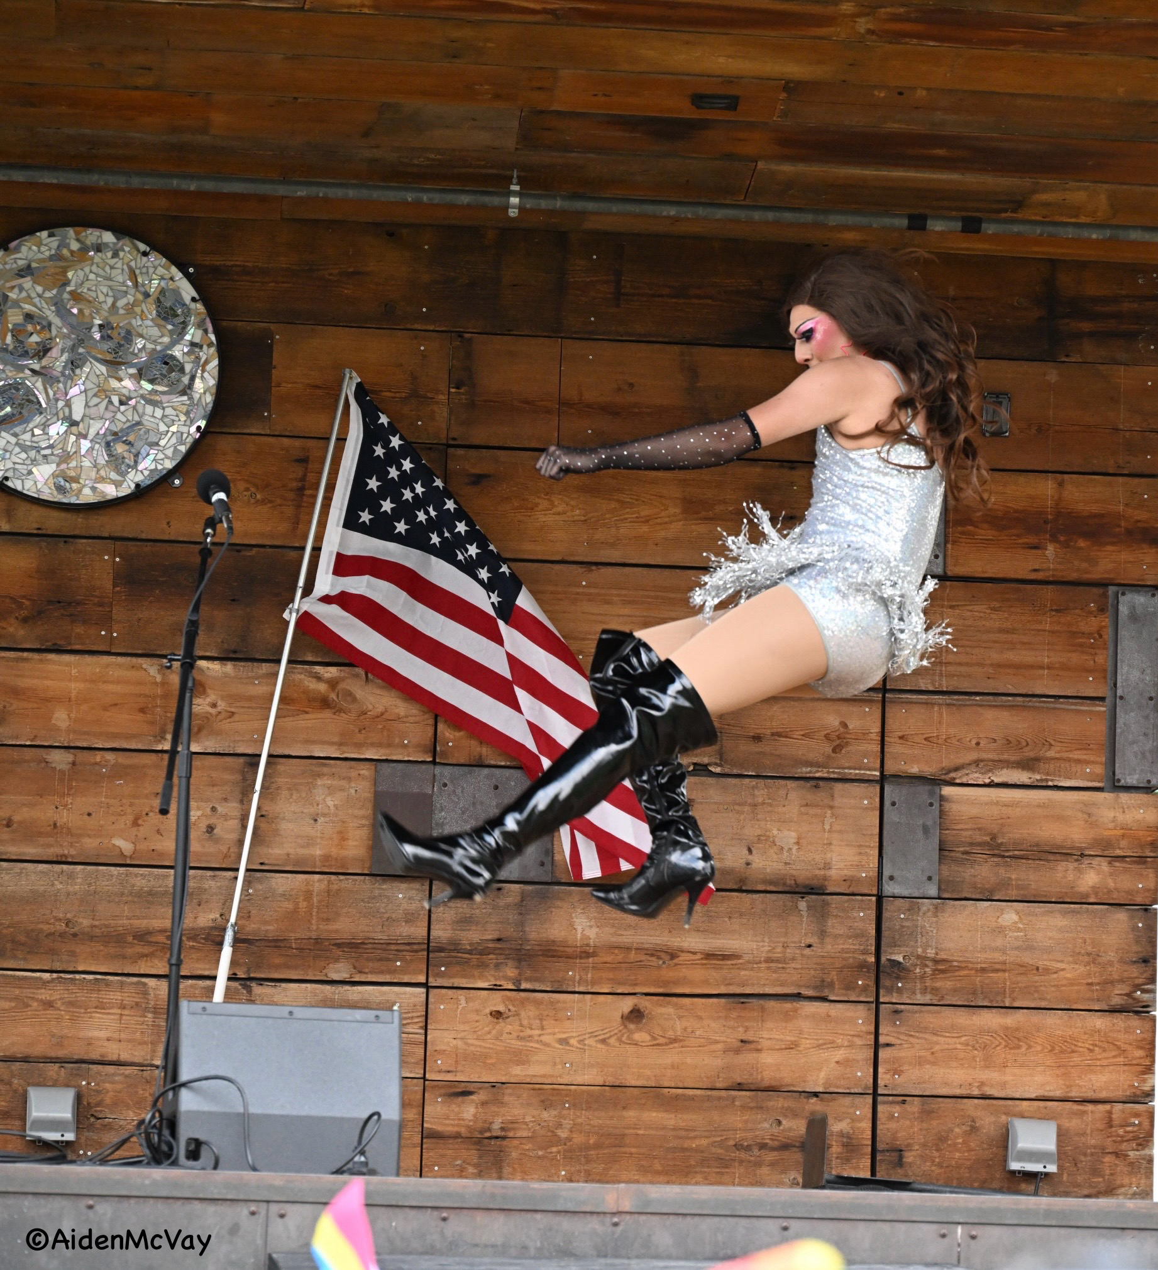
Angelique Fantastique Ouray Pride June 15, 2024

