Family Drag Show Controversy
by Aiden McVay
Family drag shows or all ages drag shows, are family friendly drag performances with no explicit material, no sexualized or inappropriate costumes, and no explicit language in the songs performed.
So what is the controversy? Especially since there is a long history of drag. According to a PBS, “Drag is the art of dressing and acting exaggeratedly as another gender, usually for entertainment such as comedy, singing, dancing, lip-syncing or all of the above.” and traced drags roots back to Shakespeare. A National Geographic article traces the roots of drag to the theater of ancient Greece and Rome and also as a part of kabuki theater in Japan. LGBTQ+ people have always been associated with drag, but most memorably for the Stonewall riots.
Drag queens were specifically targeted and harassed by police. However, in the Stonewall riots, the drag queens were the first to fight back and truly push forward with LGBTQ+ rights. Drag isn’t just about dressing up. It’s about fighting for your rights.
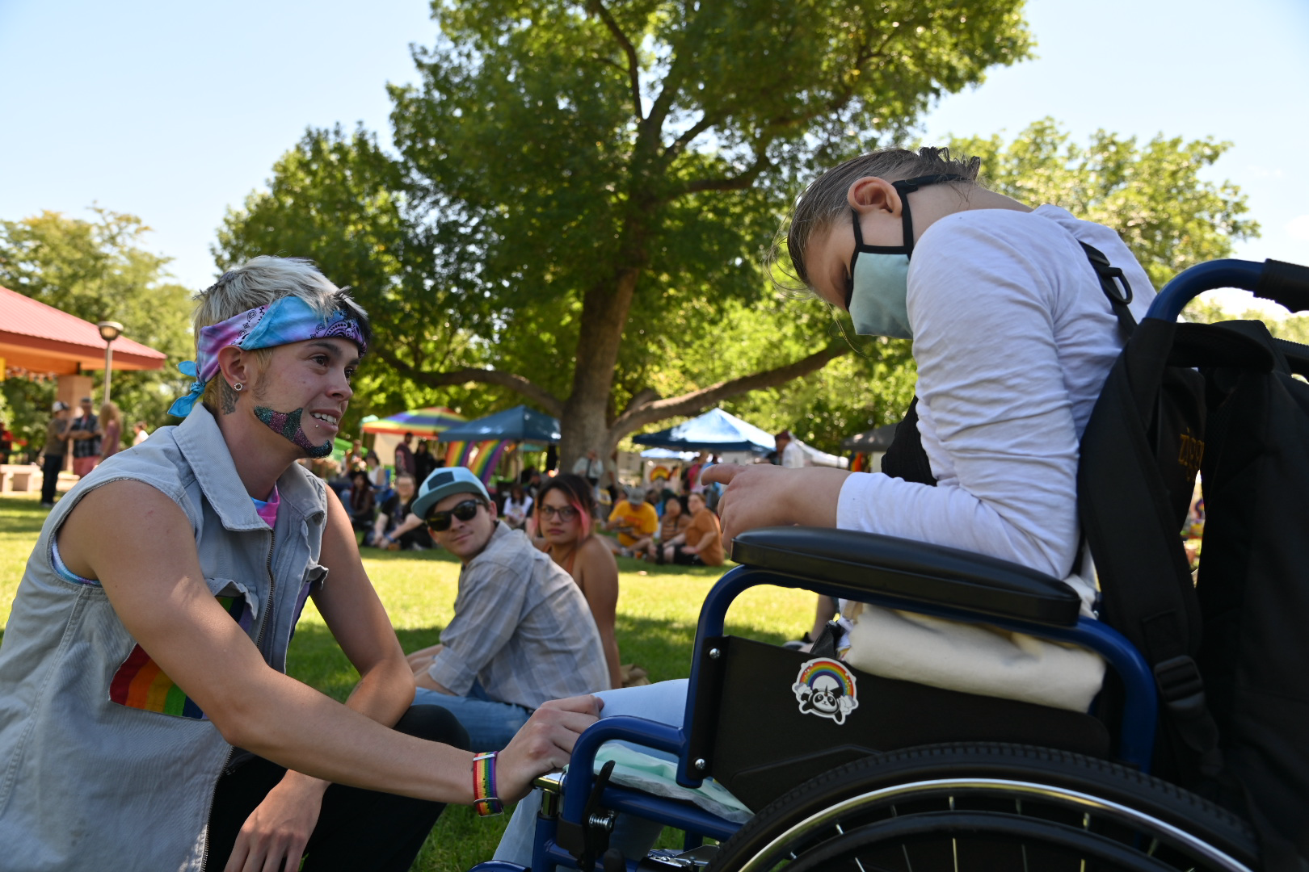Author (R) with Trenten Saenz “Peter Pan Van Dyke” (L) at Grand Junction Pride, 2023.

But that’s not how conservative political leaders see it. Tyler Lee, a republican, who ran for the US House in North Carolina in 2022, called drag queen story hour in the park “Pedos in the Park.” Florida Gov. Ron DeSantis has spoken up about drag events, “That is totally inappropriate. That is not something children should be exposed to.” And he has even suggested having parents investigated by child protective services that bring their children to drag shows. Western Colorado’s Rep. Lauren Boebert said a number of anti-LGBTQ+ plus comments among one of her most memorable, “We don’t need 6-year-old children putting dollar bills in the thongs of grown men shaking and twerking in front of children … that is child abuse.”
It’s not just the republican politicians that have a problem with an all ages drag show. It is also members of our community. In order to ask the people their thoughts, I posted my question about a family drag show on my local message board on Facebook and this is what they had to say.
Dave Kitterman said “Just clean degenerative fun. Ridiculous you think this is normal behavior.”
Terry Polsfut chimed in with, “…it’s politically motivated and you know it.” Terry also made his opinion known by stating, “Nothing clean about adult drag shows as they pertain to children.”
“ That doesn’t make it OK to put that stuff in front of children, especially without parental consent.“
Terry Polsfut did not respond to any of my further questions, and neither did the Facebook community members respond to if they had actually been to any family drag shows. Some however did private message me and answer my questions.
Jessica Ochoa-Kuykendall stated, “I have not been to a family drag show. Nor would I be enticed to take my children to a family drag show. I believe in tolerance and teaching it to children, but I don’t need a family drag show to teach them that.” She continued, “I was raised in a church and was taught that men/boys shouldn’t dress in women’s/girl’s clothes. It may confuse children on the definition of what a man and a woman are.”
Of the multiple responses that I received on the opposition a family drag shows, not one had actually been to an all ages drag show. Not all responses were negative however, some were extremely neutral, such as Terry Inloes when he stated, “As for family drag shows, parents must make decisions for their own family what is appropriate and what is not.”
Some responses were very positive. Billy Coley said “It is a form of entertainment that actually has a long history (generally speaking). No. To me, it is no more of a moral issue than the theatre, movies or TV in general.” He continued, “As a person with a theatre and standup comedy background, seeing people perform and seeing how the response of, and interaction with, the crowd is amazing to me. And the way the crowd reacts, the laughter and everything is amazing. It is a win-win situation.”
Andrea, Gray-Hoover said “ It is a chance to be entertained and show children the wide and wonderful world out there for them.”
But are any of the conservative Republican politicians or opposing community members correct in their assumptions? Absolutely not. In adult drag shows there is sexual innuendo, explicit language, and dancing but none of this exists in the family friendly drag shows. And the all ages drag shows there are flashy, gender bending performances, brightly colored costumes and a genuine theme of love and acceptance.
Renee Shirley, a cohost of the first ever family friendly pride event in Montrose, Colorado stated, “At our family friendly event, performers were encouraged to remain sober during the kids portion, encouraged to wear outfits appropriate for all ages and to perform songs appropriate for kids. The hope and goal was to inspire our community to connect, be bold and brave and to be role models for younger children. We talked about suicide prevention, bullying prevention, accessing trusted adults and building self esteem. We had activities to do for kids and their parents!”
A Northwestern University article quotes, Ricky Hill, who is a research assistant professor an expert in transgender mental health “…so to pre-suppose that all drag performances are rooted in sex, and therefore must be banned shows that lawmakers don’t fully understand that which they are trying to legislate.”
We also need to look into all ages drag show as a way for the LGBTQ+ community to get support because LGBTQ+ plus youth are at a higher risk of bullying and suicide then they’re straight peers.
In an article in Psychiatric Times, cited a 2020 national survey that 29% of LGBTQ+ plus have experience homelessness, been kicked out of their homes, or have run away. The article also reports that adults who reported higher levels of family rejection in their youth were eight times more likely to serve suicide almost six times more likely to experience high levels of depression, and three times more likely to use illegal drugs and engage in unprotected sex.

