It’s a Crime to be Gay
By Aiden McVay

Worldwide, 63 jurisdictions have LGBTQ+ bans; of those, 12 countries have the death penalty as a potential sentence for LGBTQ+ people.
The Human Dignity Trust website offers a map and list of countries that criminalize LGBTQ+ people, as well as those countries that enforce the death penalty for the LGBTQ+ community.
Of the countries that enforce a death penalty for LGBTQ+ people, eight are in Asia: Afghanistan, Saudi Arabia, Iran, United Arab Emirates, Yemen, Pakistan, Brunei and Qatar, and four are in Africa: Somalia, Nigeria, Mauritania and Uganda. All of those countries, except Uganda, have death by stoning as the punishment. Under Ugandan law, life in prison is the punishment, but the government also states that it imposes the death penalty.
It’s not just foreign countries that have LGBTQ+ bans. According to the Human Rights Campaign, in 2023, over 520 anti-LGBTQ+ bills were introduced in state legislatures. Over 220 bills specifically targeted transgender and non-binary people, and over 70 anti-LGBTQ+ laws were enacted in 2023. The HRC breaks it down—Laws banning gender affirming care for transgender youth, 15: Laws requiring or allowing misgendering of transgender students, 7: Laws targeting drag performances, 2: Laws creating a license to discriminate, 3: Laws censoring school curriculum, including books, 4.
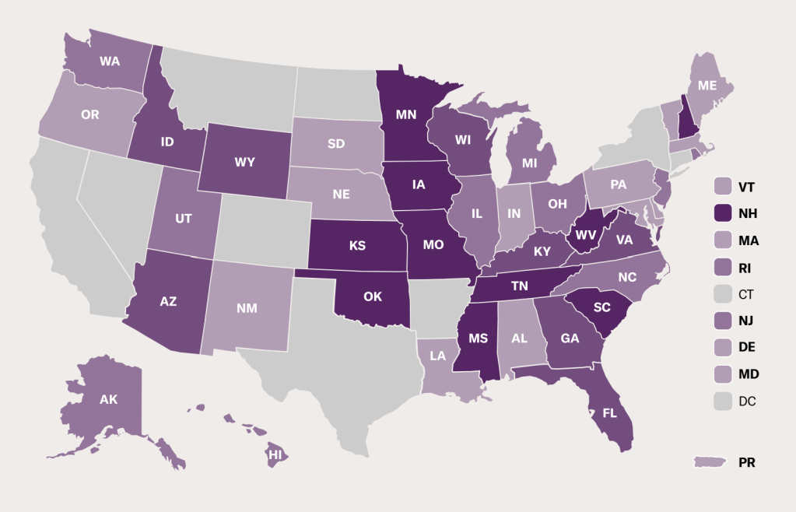Courtesy of the ACLU.

The American Civil Liberties Union also tracks anti-LGBTQ+ legislation. Of the 530 bills, they are currently tracking 31 introduced bills, 104 advancing and 44 already passed into laws across state legislatures. This year, Tennessee tops the list with 13 of 44 active laws in the United States. Utah comes in at 6, Idaho at 5 and Iowa at 4. In 2023, Texas had 6 active anti-LGBTQ+ bills, Colorado had zero and North Dakota rounded out the top of the list with 10 laws of the total of America’s 84 anti-LGBTQ+ laws in place.
But where did anti-LGBTQ laws come from? Homophobia? Religion? Unfortunately, no one knows for sure, but looking at some of the earliest anti-LGBT legislation, it seems it originates from religion. According to Stonewall, British colonialism imported homophobia to the African countries under the commonwealth. Countries formerly ruled by Britain have the most severe anti-LGBTQ+ laws. This appears to stem from Christian rule dating all the way back to Henry VIII and continued with Christian missionaries.
Closer to home, anti-sodomy laws existed at the state level since the 17th century. Even Colorado adopted British common law when it entered the union, which allowed for the death penalty for acts of homosexuality.
The history of anti-LGBTQ+ legislation at the federal level in the United States is less clear, but many point to the Immigration Act of 1917, which restricted immigration to people with “constitutional psychopathic inferiority,” a classification used to discriminate against people because of their sexual orientation.
Considering modern legislation’s blatant disregard for separation of church and state, one might assume that text from the Bible is influencing our Congress and state representatives. Although the people spewing hateful rhetoric cite biblical passages for their “moral reasoning,” their evidence is severely lacking, as the word “homosexual” wasn’t translated that way until 1946.
The biblical passage claiming homosexuality is morally wrong in Leviticus contains only two Greek words, malakoi and arsenokoitai, for which the original translation was “boy molesters” rather than homosexuals, and was most likely referring to Levitical priests and laws.
Regardless of one’s religious faith or the books they follow, it has no place in our legislation. We have a duty to make sure that everyone regardless of race, religion, disability or sexual orientation be treated with equality. And right now, our nation, along with many other countries, is denying our human right to exist. We all must protect each other, and if any of us are not free, then none of us are free. So, I encourage you to stand up, vote, protest and live as who you truly are.

