Meet Kandrii Zavalla
By Aiden McVay
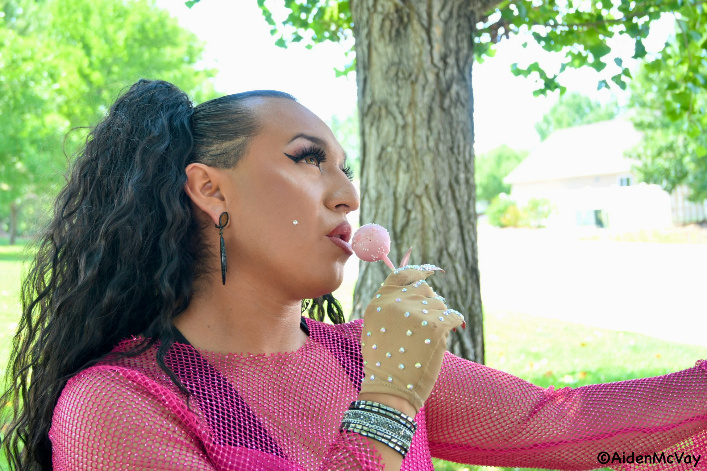Private photo shoot, Montrose. Photo by Aiden McVay.

Kandrii Zavalla is a dynamic drag performer. She is a drag queen on the Western Slope that has mastered numerous looks with her style, make-up and pronounced profile. I recently had the pleasure of interviewing Kandrii about her performances, goals and inspiration.
Aiden McVay: What are your pronouns?
Kandrii Zavalla: He/him; unless in drag then she/her.
AM: Where were you born?
KZ: I was born in Mexico, in Yucatán.
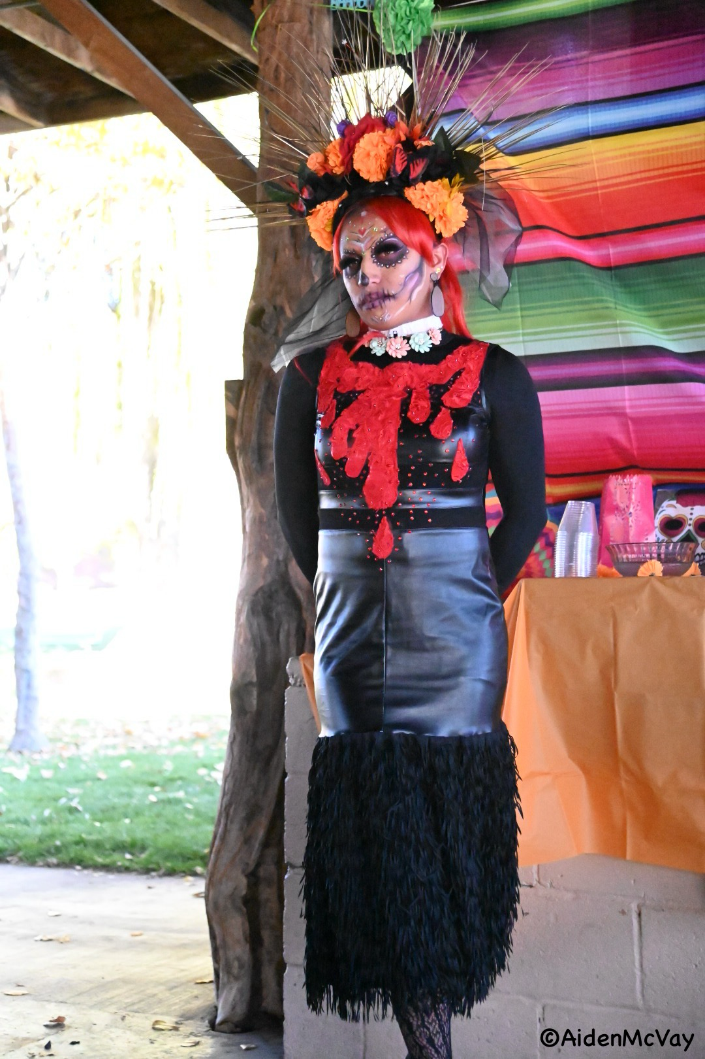
Dia De Los Muertos Celebrations 2023, Delta Colorado. Photo by Aiden McVay

AM: When did you move to Colorado?
KZ: I’ve lived here since I was seven years old.
AM: How did you get started in drag?
KZ: I started by doing makeup. Like contests or giveaways through Facebook. It wasn’t necessarily drag, but it started my experimenting with makeup and that type of thing.
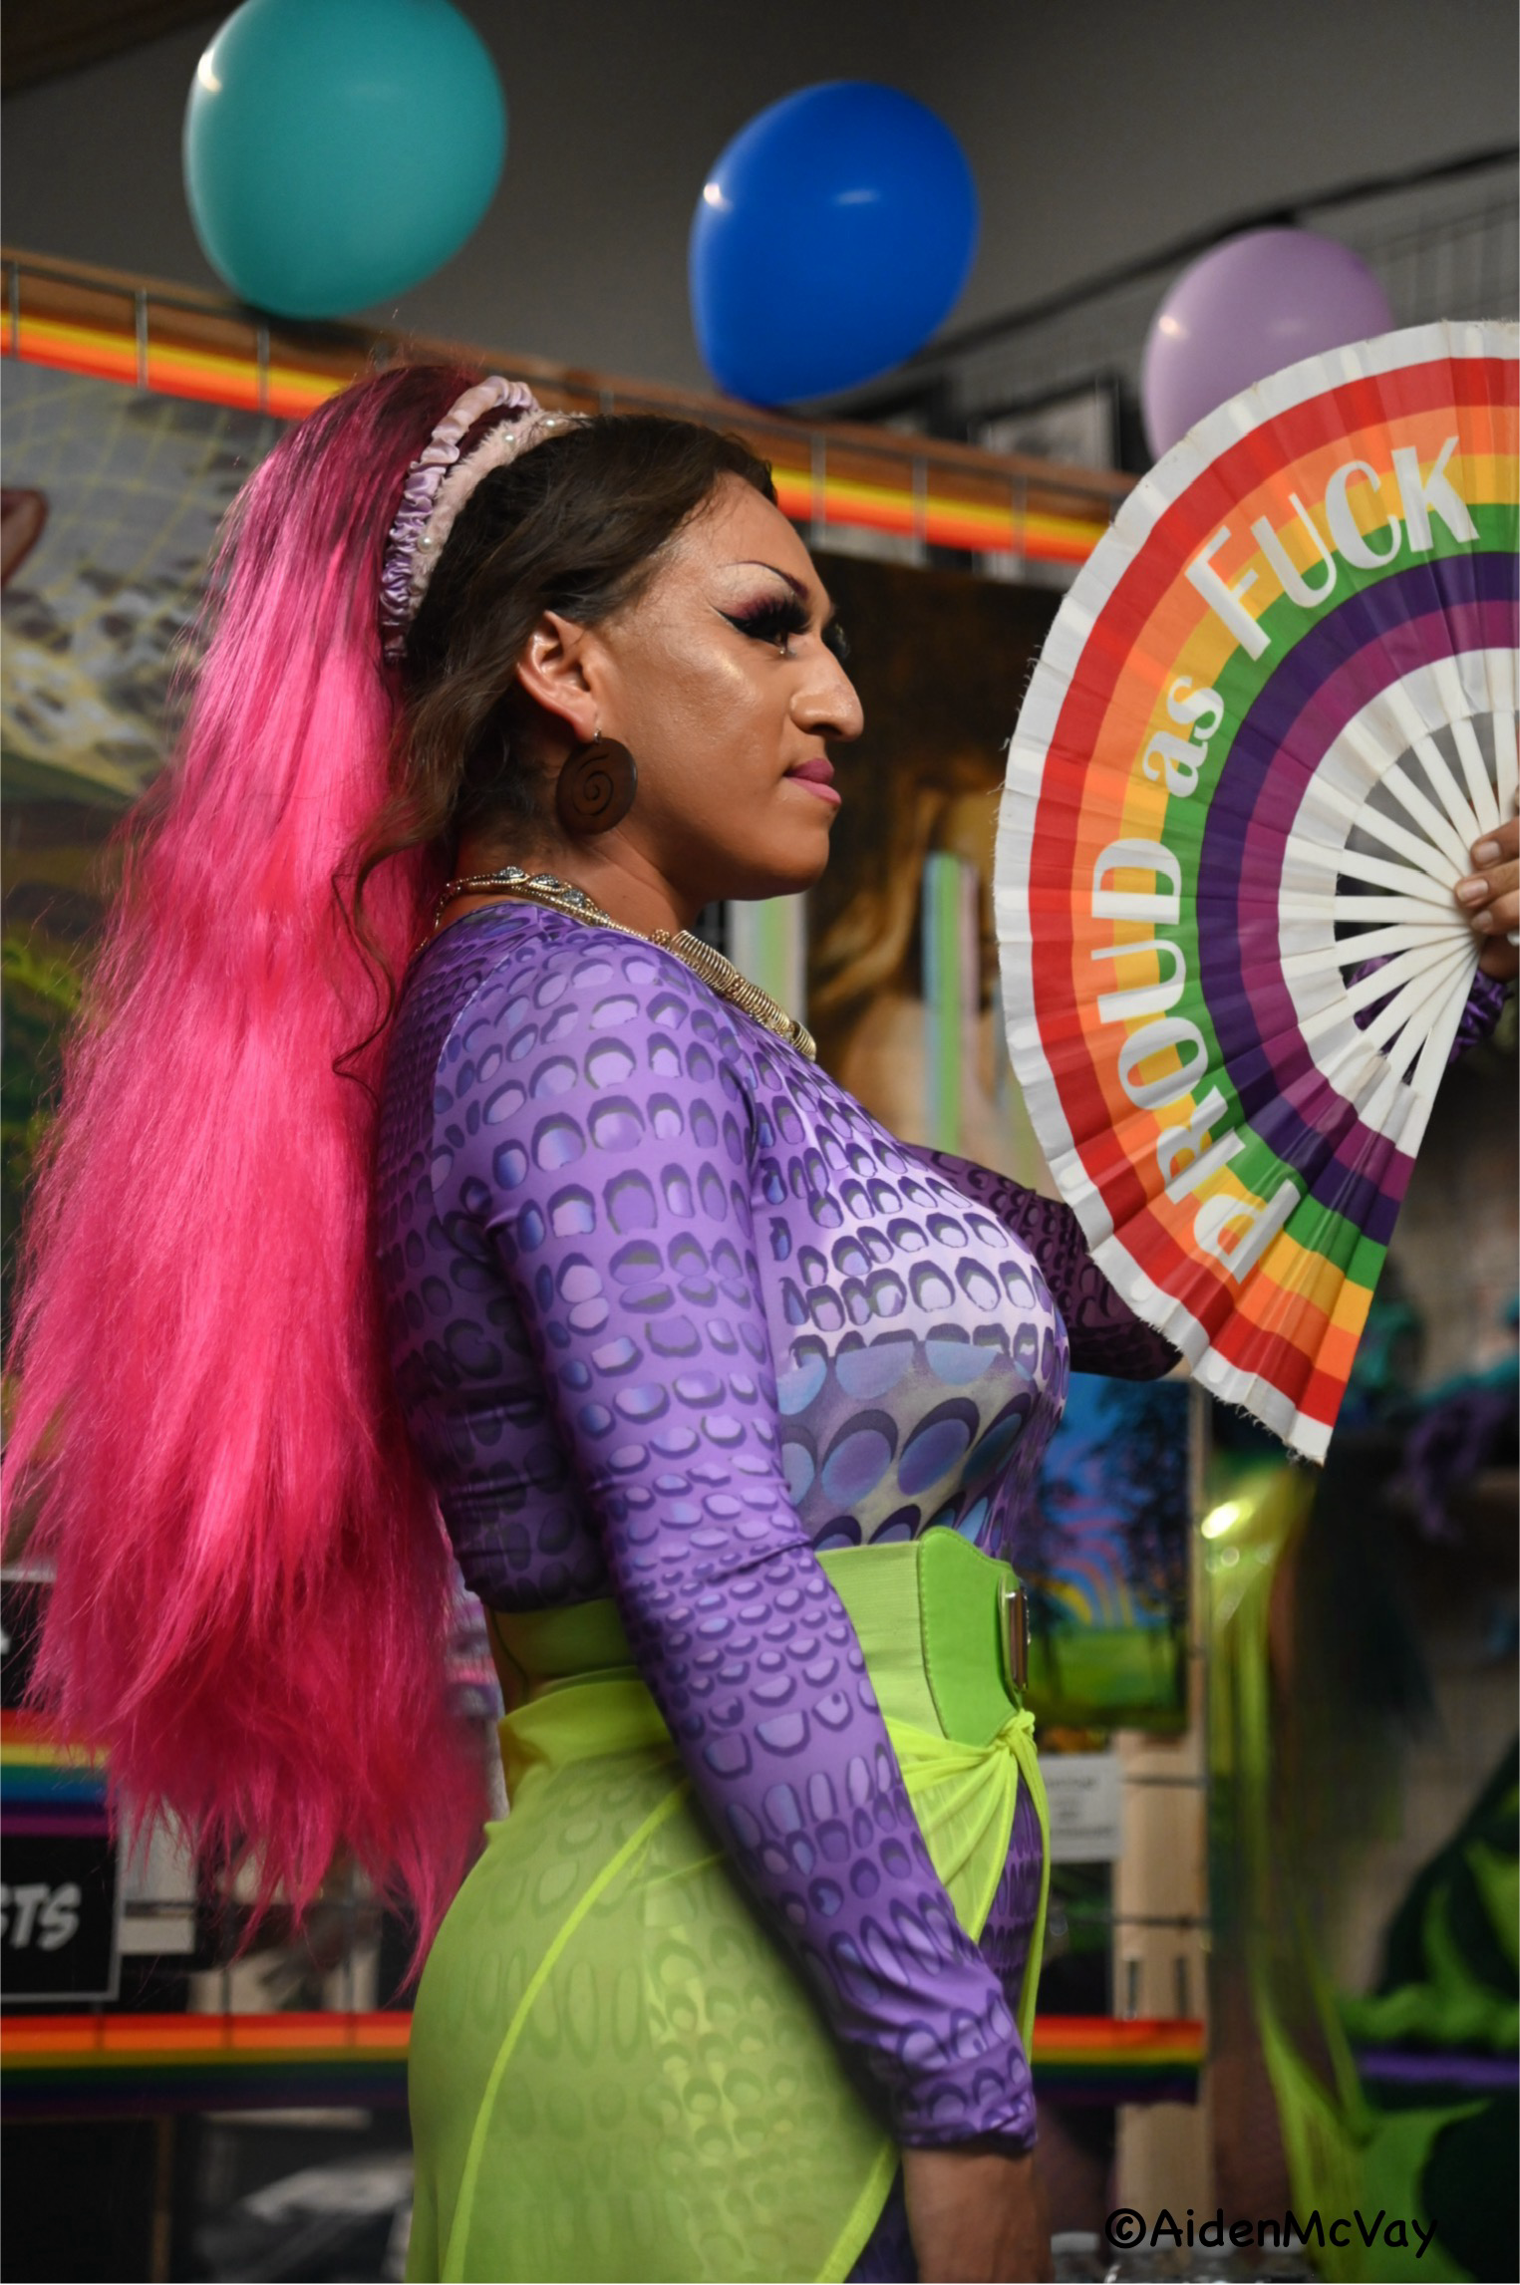
Uncanny Gallery, Grand Junction. Photo by Aiden McVay

AM: When did you start performing drag?
KZ: 2016 would be the first time I started officially performing. My first venue I performed was at Baron’s in Grand Junction.
AM: What are your goals for drag and performing?
KZ: Oh gosh, I have so many, but my main goal is just to be, this sounds so crazy, but like a drag superstar.
AM: What are your drag inspirations?
KZ: Dolls, dolls, dolls, and my inspiration just comes organically.
AM: How do you come up with your looks?
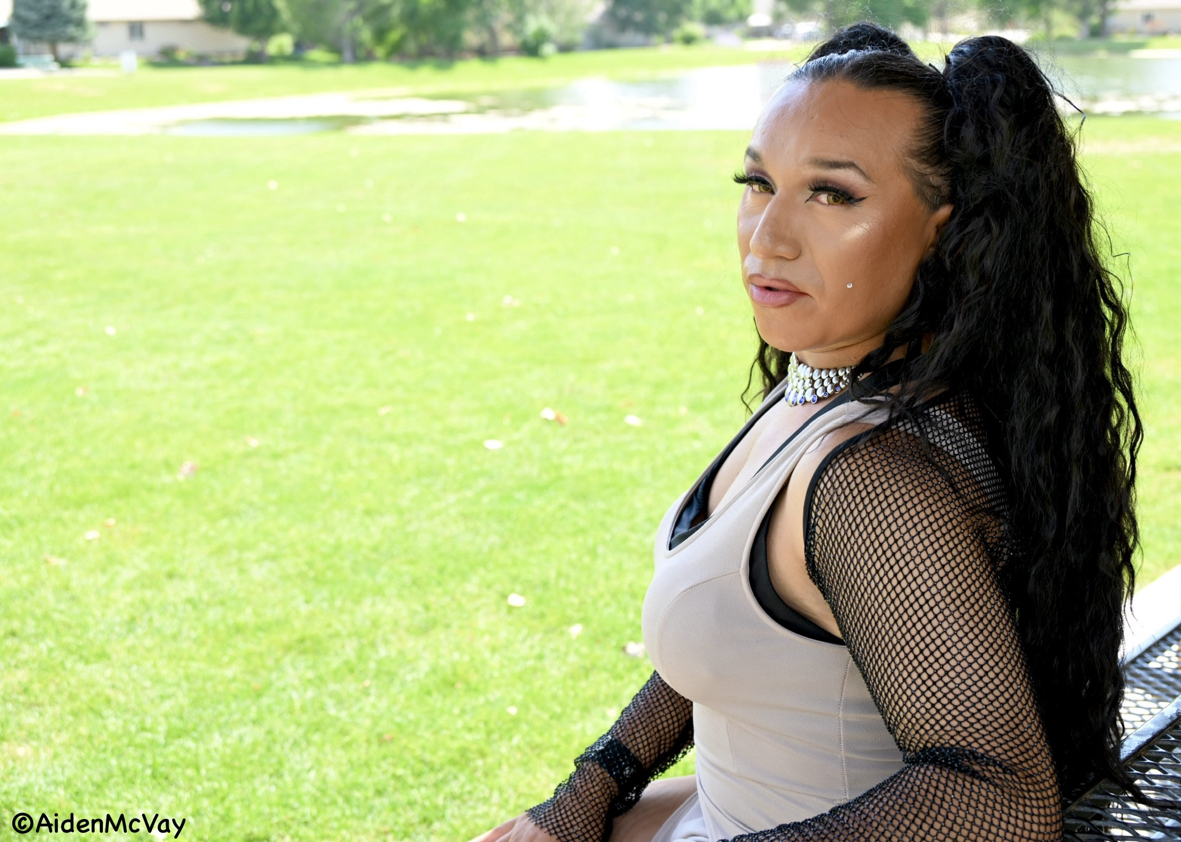
Private photo shoot, Montrose. Photo by Aiden McVay.

KZ: None of my looks are really planned; just like it comes day by day.
AM: Where do you see your future in performing/drag?
KZ: Hopefully, it’s more at like different venues and around either the state or even the country. I would love to perform in Mexico. Of course, like one day I would like to see my future in drag just as growing for myself and I would like it to be full-time.
AM: Do you find it hard to make a living performing?
KZ: Yes, but the fact that I get paid to perform—it’s just amazing.
AM: Where have you performed?
KZ: Charlie’s Dwellingtons, what is now Good Judy’s, The Cesar Chavez Event I’ve done for a few years now, I’ve been at a Halloween Drag show for Mesa theater, And I’ve done some shows with the Roaring Divas from Glenwood Springs, Glenwood Pride, Delta Pride. Mountain Pride in Avon this Year, Montrose Pride, Ridgeway Pride. I’ve been To Telluride, Durango, and also have done a few private parties lol.
AM: What is your favorite venue that you have performed at?
KZ: My absolute favorite place has been in 2019, for the Denver Pride Latino stage. I was offered a 27 min time on Stage. I performed it with my partner and a mix of songs and the crowd was incredible! So many people there when I was on stage! I had the best time!! There’s a video my family recorded too because they went to watch me that time too.
AM: What advice would you give someone starting off in drag?
KZ: We as drag artists, we make it look easy, and sometimes it’s like we don’t show the hard parts to it, but just keep going. Like anything in life, anything that is hard, if you keep going, you’ll finally find your niche, you’ll find your family, and you’ll find people that enjoy your type of art or your type of style of drag.
Kandrii Zavalla’s Latinx energy and stage presence is one you don’t want to miss!
You can see her perform at the 2nd Saturday’s monthly drag show at Good Judy’s in Grand Junction.

