Pride Mural Sparks Emotion; Empowers Youth

Photo and Words by Aiden McVay
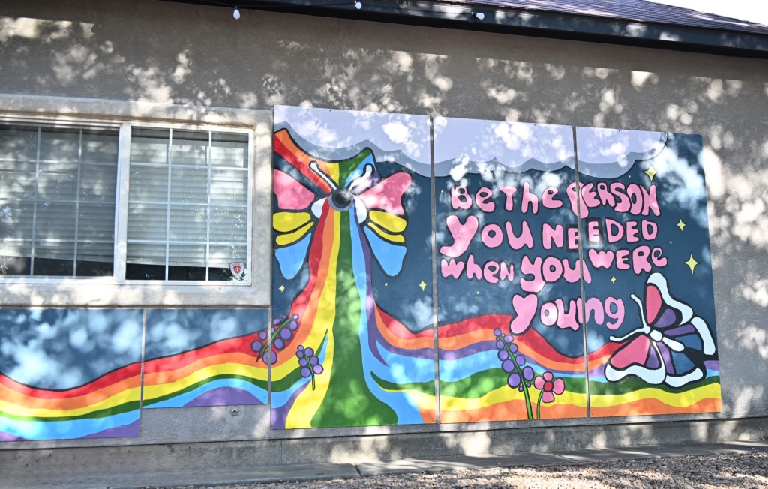Mural at Loving Beyond Understanding’s The Center

“Be the Person You Needed When You Were Young.” That is the message the Bam Biz Art Mentorship wanted to convey on their LGBTQ+ inclusive mural, unveiled Sunday, September 8. The mural is Grand Junction’s first ever LGBTQ+ mural and is located at Loving Beyond Understanding’s The Center.
Tauma Lee, founder of BAM, said that the youth wanted to do a pride mural for their production and that the program was there to support them. The muralists have been working on the project as a work-study program since April 2024. The twelve young artists worked on the mural with the help of lead muralist Emily Adamson, Assistant Muralist Angelina DeCrow, and Mural Crew Support & Youth Coordinator, Evelyn Greenman-Baird.
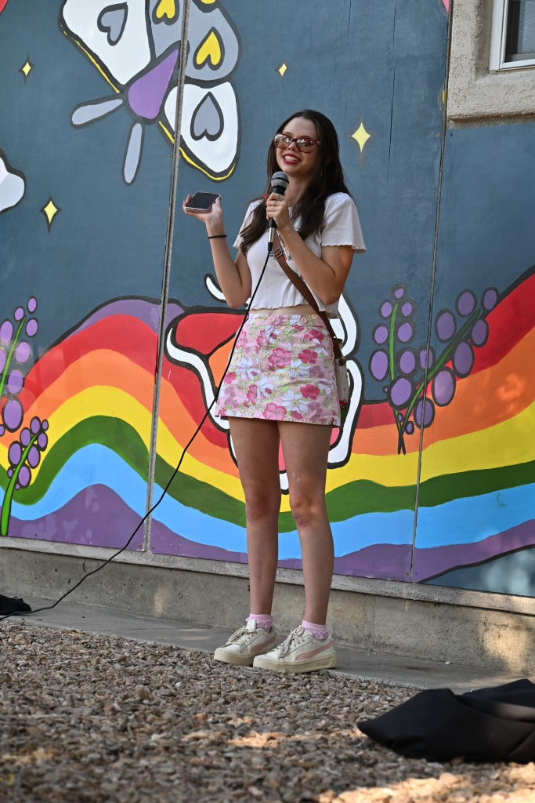
Lily Elford, one of the dozen young artists who participated in the creation of the mural, addressing the audience.

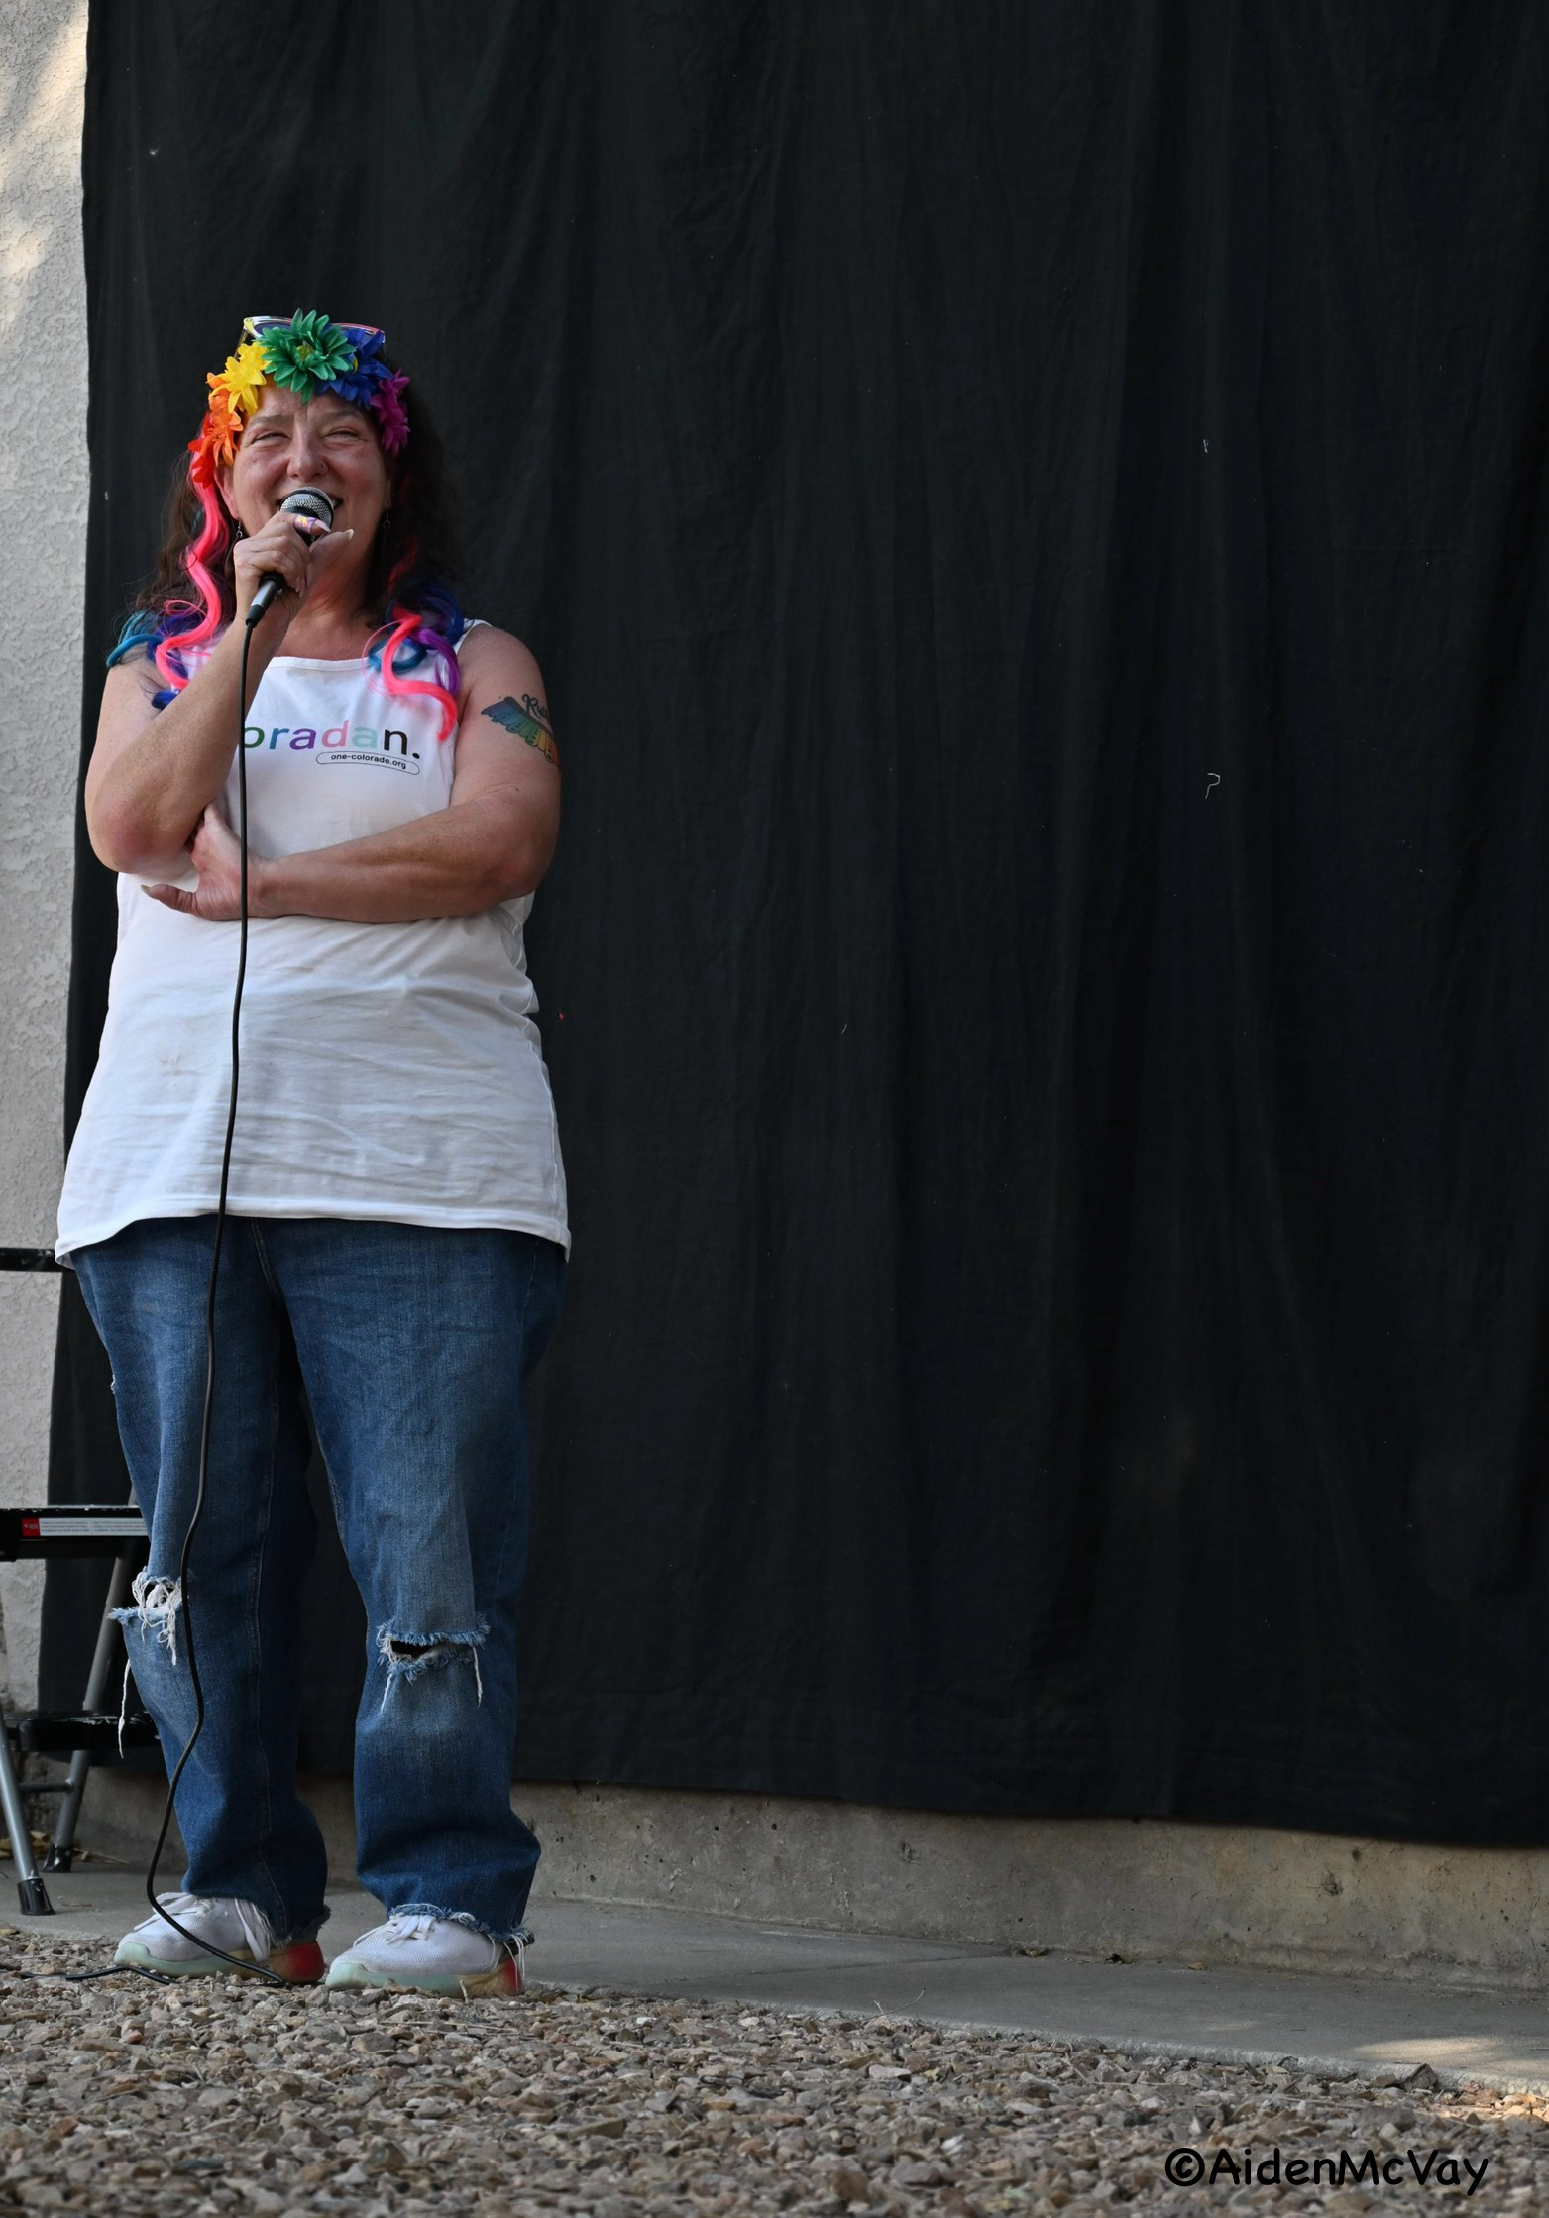
Heidi Hess with One Colorado and Colorado West Pride addresses the crowd of about 35 people.

Youth muralist, Alex Eikenberry, who has been an artist since six years of age, spoke of the inspiration for the project and its representation: “The LGBTQ+ community as a whole, where we can incorporate everything and have everyone represented.”
Heidi Hess, a founding board member of Colorado West Pride and a Western Slope field organizer for One Colorado, spoke at the unveiling and said, “[Youth is], what the world needs, and they are telling us what they want it to look like and they’re creating it, and we need to listen to them. This is my heart this week. This is the thing this week that makes me cry.”
Heidi wasn’t the only one who had their emotions brought to the surface. The mural’s inclusive message, the youth artists’ speeches and the overall atmosphere brought both tears and joy.
The message is clear from BAM’s press release: “This mural serves as a vibrant symbol of hope, unity and community PRIDE, as well empowerment for marginalized youth in the Grand Valley.”
The mural will be at Loving and Beyond Understanding’s The Center for the next year. For more information about having a mural installed at your LGBTQ+ affirming businesses contact BAM! at admin@bambizart.org

