Small Time Drag, Big Time Heart
Story and Photos by Aiden Mcvay
Drag King, Xavier Van Dyke, may come from a small town, but he’s doing drag in a big way.
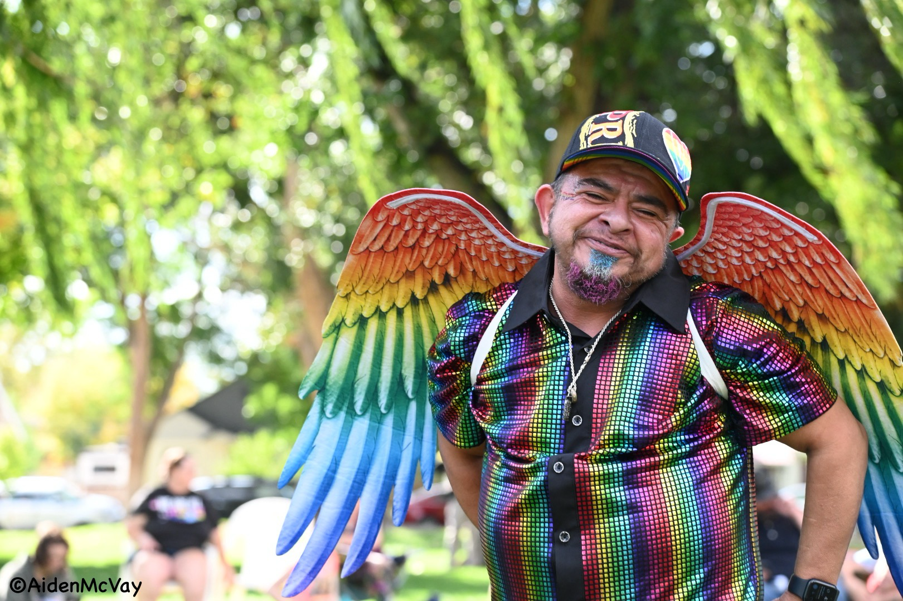Xavier Van Dyke, Delta Pride, 2023.

The first thing I noticed about Xavier was his intoxicating smile. Being blind, sometimes I miss the details, but with him, I couldn’t take my eyes off of his face. His energy drew me in as well, and made me feel at home. I can understand why he is such an extraordinary performer.
Xavier Saenz is a 50 year old transgender man that was born and raised in Delta Colorado. Although he only started his transition seven years ago, it really began for him in “6th grade pretending to be a boy in my room wanting to be a rockstar,” he recalled.
I asked Xavier if he’d experience bullying, to which he replied, “I didn’t remember. I did have a lot of friends who said I stuck up for them…I think I’ve been bullied more as an adult by adults than anything.” He survived by developing coping skills and support from his sister. Xavior mentioned she even comes to his performances.
Xavier started the Van Dyke family 25 years ago when he started performing. I asked him where the name came from and he said, “Drag names spoofs off other famous people. Dick Van Dyke and Spic Van Dyke, those were the only two things that anyone could say about me negative.” So Xavier Van Dyke was born and was created quite literally from the negative slurs that people would call him. Not only did he embrace the negative, he created something beautiful from it.
I have had the privilege of seeing Xavier Van Dyke perform, and I was mesmerized at first glance. His smile drew me in and his movements and energy captivated his audience. He brings people on stage with him and I have even been so lucky as to capture some of these moments on camera. It’s not just during a performance that Xavier brings people in. Lexi Glidden said, “Xavi took me under his wing when I was in the beginning of my transition… He sheltered me, and made me feel safe and loved… He gave me what I needed to grow.”
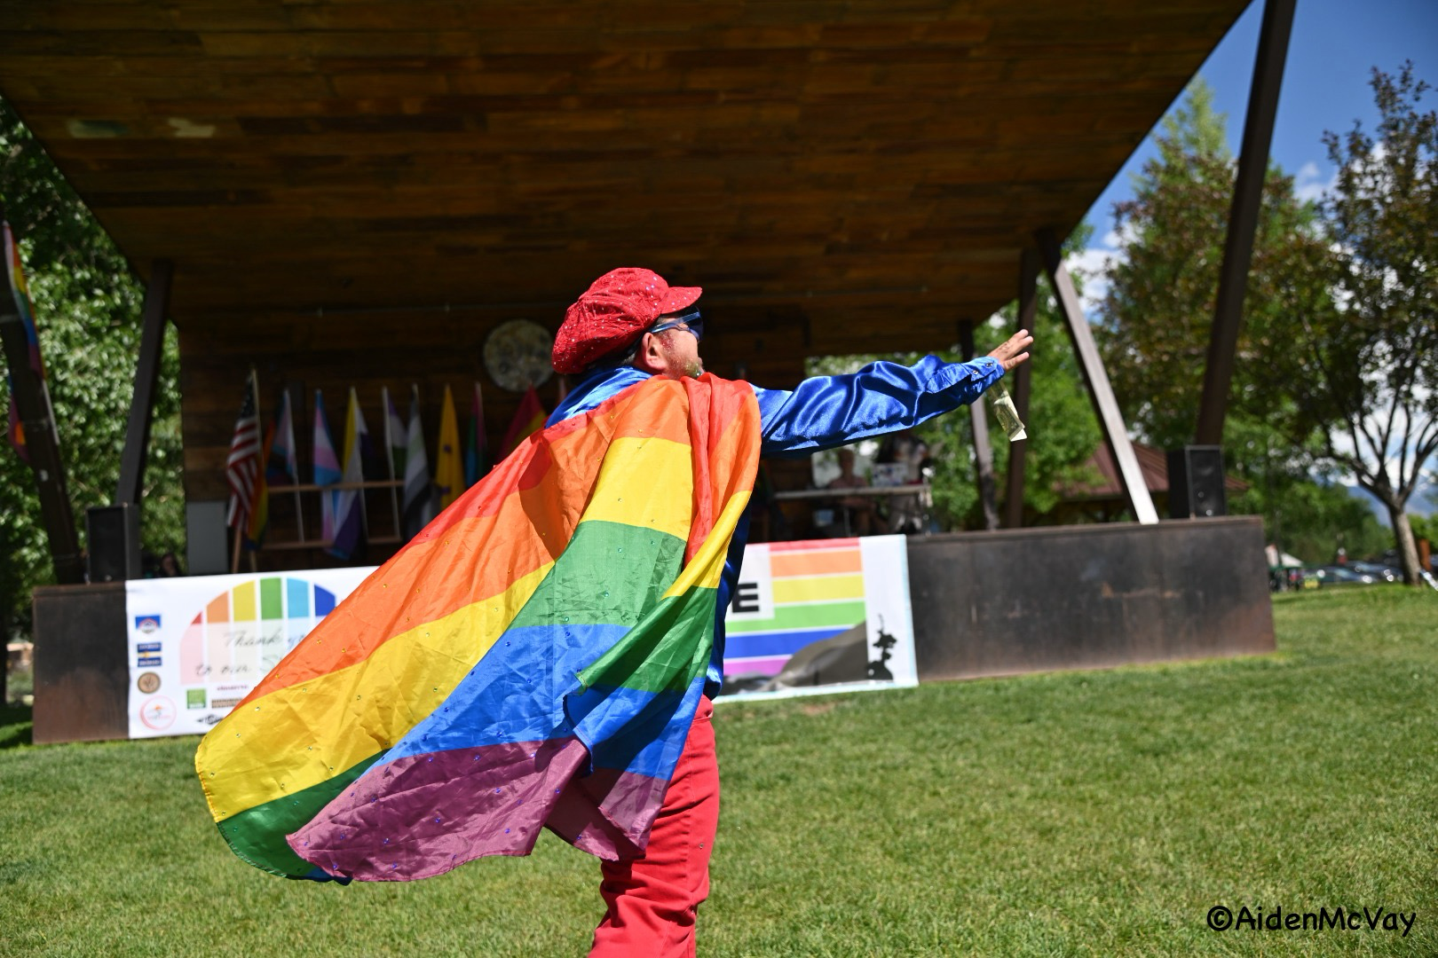Xavier Van Dyke, Ouray Pride, 2023.

It’s not just the small town performances that have got noticed either. Xavier and the Van Dyke family have been featured on HBO’s show “We’re Here.” In season 2 episode 8, Xavier‘s drag son, Dustin Van Dyke got to perform and shared some beautiful things about him. Dustin said, “Xavi has done a lot for performers like myself, giving us a place to be themselves and be open.”
Xavier has inspired many including his drag family. Leondre Nave said, “I love his big heart, and how he isn’t afraid to be himself. He lets people into his family and is so supportive of every single person.“ Eli Bauguess called Xavier “…an inspiration I wish to become.“ When asked, if you could tell Xavier just one thing what would it be? Carson Saenz said, “I would want him to know how grateful I am to be his son. I wouldn’t be the man I am today without him.“
And when asked to describe Xavier in just one word the Van Dyke’s offered “thoughtful, compassionate, loving, King.” But the word that most accurately describes him was “home“.
That was his response when I asked him if he could do anything, what would it be? “I would have a huge home that anyone who needed a place would have one.”
Xavier said, “That’s one thing that’s different about the Van Dyke family is that we’re a chosen Family.” He told me, “You were chosen too.” And he was right. I wasn’t just Aiden Mcvay, disabled, non-verbal, and invisible. I was Honey Van Dyke, author, photographer, future performer. But more than that, I was family.
That’s what Xavier Saenz, Xavier Van Dyke does, he builds family.

