Stella Rae Wins Diva Award
By Aiden McVay
Stella Rae Van Dyke was co-awarded the Breakthrough Artist Award at the 5th annual Drag Initiatives and Variety Awards (DIVAs), on Feb. 22nd. She also was nominated for best drag show for her regular Second Saturday show at Good Judy’s in Grand Junction.
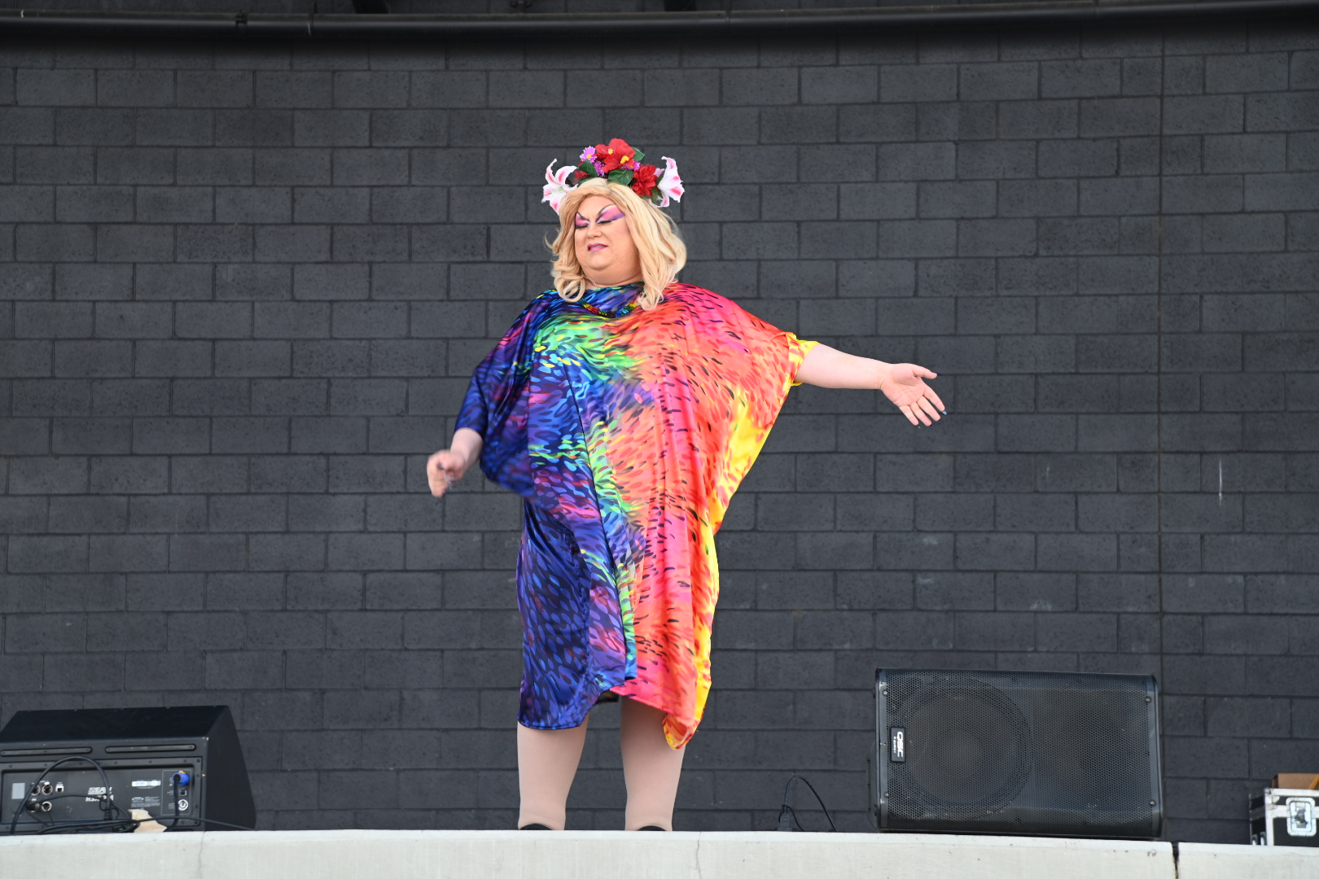Stella Rae at Cesar Chavez Celebration, March 2024, Grand Junction. Photo by Aiden McVay.

Stella Rae is not only an exceptional drag performer but a fantastic DJ, MC, speaker and comedian. But she truly shines as a drag performer, and I have been lucky enough to see her perform multiple times.
Stella Rae started performing in 2012 but her love of drag goes back as far as she can remember. “My most tightly held visions of my adulthood involved running a drag show that raises money for the community,” Ms. Van Dyke said. “Drag is liberation, freedom, and joy.” And Stella certainly shows this in her performances. Stella Rae continues “For one special moment, everyone in the room is working together to create a moment of art.“
The art of Drag is such an important part of the LGBTQ+ community’s past and future. Stella Rae Van Dyke said “The most important thing that any of us can do is hold space for another person,” and she does exactly that. So thank you Stella Rae Van Dyke and our other local drag performers for giving us some much-needed joy. Congratulations on your award!
You can see Stella Rae Van Dyke regularly at Good Judy‘s in Grand Junction, Colorado.

