Thousands Come Together with PRIDE
By Aiden McVay
This year, Grand Junction Pride, hosted by Colorado West Pride, was bigger than ever. There were an estimated 3300 attendees and 75 vendor booths along with a star-studded drag show and food trucks.
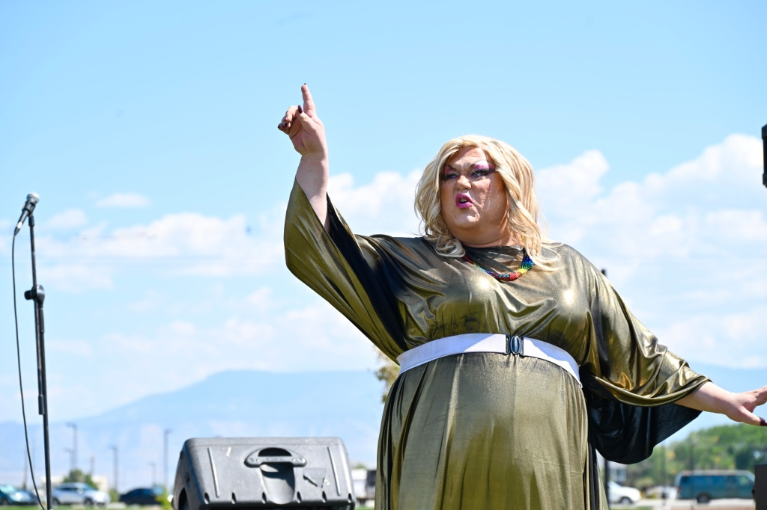The one and only Stella Rae Van Dyke. Phot by Aiden McVay

Colorado West Pride was founded in 2014 “as an LGBTQIA+ community event & outreach organizer. We have been the host & primary event organizer for Pride events based in Grand Junction, and serving Western Colorado & Eastern Utah,” according to the CWP Facebook page monitor.
Pride hosted a variety of vendors, from churches such as Unitarian Universalist Congregation of the Grand Valley to the Colorado Satanists, local business Revolution Cycle, and resin artwork creator Daizy McCarty and newcomer Amber with Differently Abled Designs.
McCarty commented on the event: “Grand Junction Pride 2024 was a potluck of queer creatives and all their amazing talents! We are so honored to be a part of this massive celebration and love getting to meet members of our local community!”
Amber, first time vendor of Differently Abled Designs, wanted a “chance to show off my talents as a creator/crafter and eventually turn it into a business and help the differently abled community to thrive and create their art.”
But Grand Junction Pride wasn’t always so big.
Heidi Hess, Community Engagement and Education Director and founding board member of Colorado West Pride, said, “The first pride had under 10 booths and fit on the lawn of the old Courthouse at 5th and Rood.”
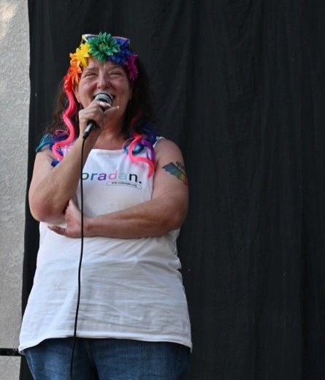
Heidi Hess speaks the unveiling of the of the BAM Pride mural, at Loving Beyond Understanding’s The Center. Photo by Aiden McVay.

“Both seatings of the Rainbow Party sold out, and the Glow Party was at capacity!” Hess stated.
Zen Fatale, co-founder of the Roaring Divas and mother of the House Fatale, performed at the sold-out show, The Rainbow Party at Good Judy’s. She said, “We need to do Pride events, because drag is an integral part of Pride. Drag performers, Trans people, etc., have always been at the forefront of our community. We have led the protests and the parties; drag is a living protest.”
Zen’s drag kids, Angel Fatal Spectrum, Axel Spectrum, and Scarlet Fatale performed at Pride on Saturday. They are all newcomers that have only been performing since spring/summer of this year but showed an immense amount of talent.
It wasn’t just the House of Fatale that performed at Saturday’s Pride.
Long-time performers, the House of Van Dyke, included Xavier, founder of Delta Pride, Madame Van Dyke, Stella Rae, Peter Pan, and new members Scarlet Rose and Vandetta.
Vendetta has only been performing for about four months. This was his first time performing at a pride and said about his experience, “I had so much fun with pride. I performed at the CMU show as well. I was very nervous before going on stage, but as soon as the music started, my nerves disappeared.”
If Vandetta was nervous beforehand, he sure didn’t show it. His music choice, facial expressions and movements were met by a captivated, cheering audience.
House father, Xavier Van Dyke, had a moving performance performed to Beautiful Things by Benson Boone, as he handed out gift bags compiled for suicide prevention. He also commented on the festivities: “When we got to the event I was greeted by my drag family and friends, some I have not seen in a year. I started to realize. This was more than Pride. This is a family reunion. Each time I get tired and ready to take a break I get reminded why I started doing this 30 years ago.”
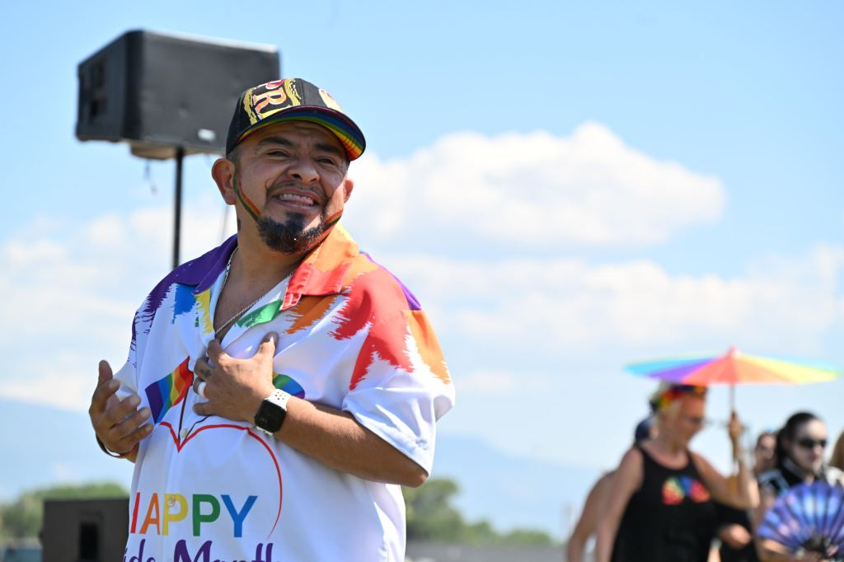
Xavi Van Dyke at Grand Junction PRIDE. Photo by Aiden McVay.

Fellow performer Craven Moore Romanova, who is not new at doing drag but has just opened a new drag house, said, “Performing for people just like myself feels extra special. Being able to connect with a crowd through emotions and art is always a good time. And being comfortable in my own skin while doing it all meant everything. I was honored to be a part of the festival and look forward to doing it again!”
But it was performer Cardi Reada who summed up what drag is about: “I would say drag is a celebration not just of gender, not just of personality, but a celebration of the self. A moment in which anyone can be more than what others think of them. Transcending singing, dancing, and acting. It is a moment to let your inner self feel joy in just existing genuinely.”
Cardi Reada, who was the victim of a hate crime during the past year, also said, “To see everyone being joyful together and celebrate themselves as well. It makes me believe in hope for the future.”
This is why pride was originally a riot. This is why we need to have pride all year round. This is why pride is important. To stand up and be brave, to be authentically ourselves, to celebrate, and have hope for the future.

