Understanding Loving Beyond Understanding
Photos and Text by Aiden McVay
Loving Beyond Understanding (LBU) is “creating queer centric spaces that are intentionally welcoming” said Emmanuel Cisneros (They, Them) director of LBU.
“Loving Beyond Understanding is a center for LGBTQIA folks to have social and support services. It’s a location for community… programming… (and) access to services that make our lives easier, better, and more joyful.” Andrea Williams (she, her), Administrator.
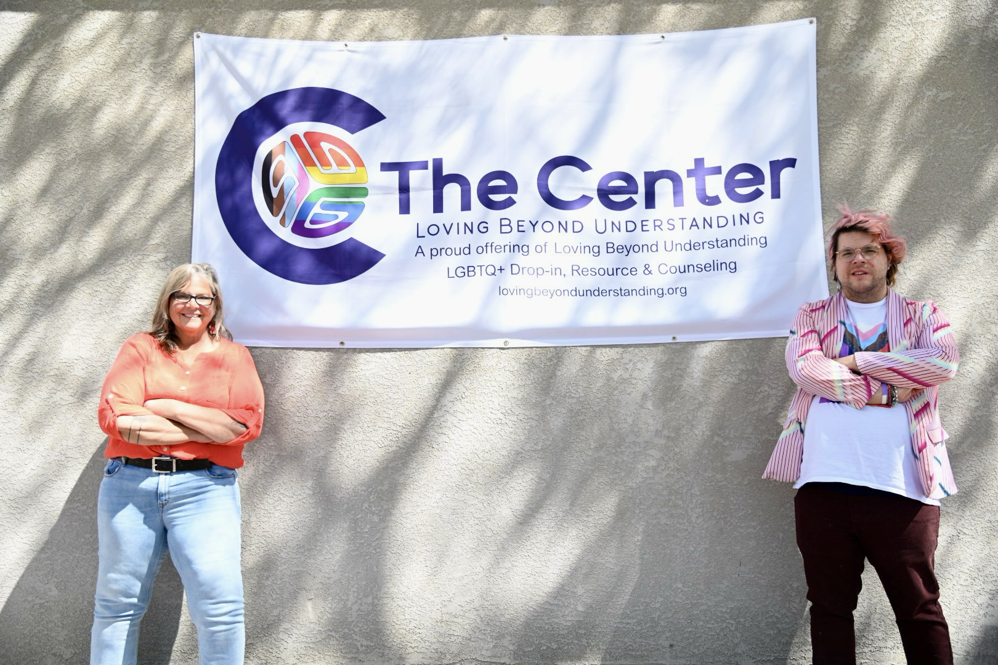At the Center in Grand Junction, Colorado. Andrea Williams, Administrator (L) and Emmanuel Cisneros, Director (R).
The programming described by Andrea Williams include banned and polyamorous book clubs (virtual option included), community potluck on third Thursday, drag practice Fridays, events for silver foxes, preteens, and peer support to help access mental health services, and job skills for employment, among others.
Emmanuel, said that the organization was created to meet the needs of the LGBTQ+ community. The center was founded by Andi Tillman (they, them) in 2022. Loving Beyond Understanding emerged from their background in conflict resolution and seeing a need for a space for LGBTQ+ youth. Andi Tillman recalls, “We started just 29 months ago with a small $7k suicide prevention grant from the Western CO Community Foundation to start support groups for LGBTQ+ teens and parents of LGBTQ+ youth.”
The Center, which now stands on South street in Grand Junction, Colorado, is a safe space not only physically, due to surveillance technology and security, but also emotionally. Pride is visible as you walk in. LGBTQ+ & Black Lives Matter murals and Frida Kahlo grace the walls. You are not only welcomed by people, but coffee, collaboration, and inclusivity. Even the structure of the building is inclusive. Emmanuel said that was a big reason this building was chosen was that they wanted it to be accessible for all. The building itself has accessibility features so that wheelchairs can enter.
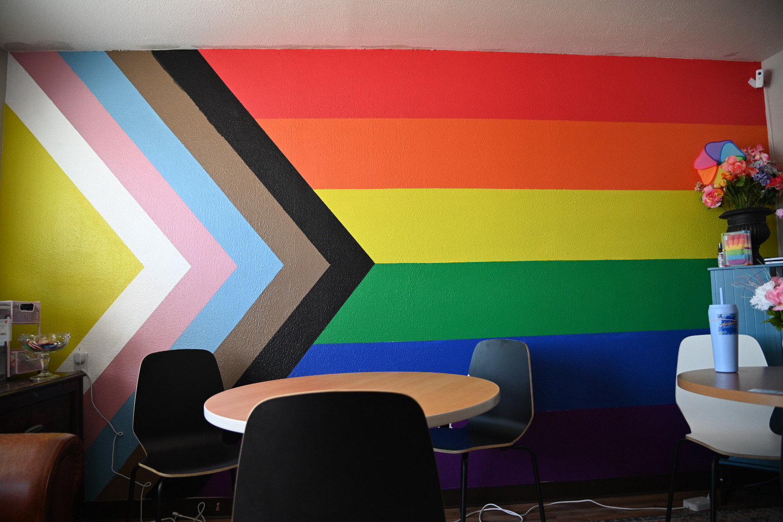Mural at The Center run by LBU.
The atmosphere here matches the welcoming architecture and decor. Li Peake (they, them), Community Resource Navigator, said about the Center, “…it honestly feels like a place where I can let my guard down and just be”. Andrea Williams described it as “It’s like being home.” The art, the coffee, the well stocked kitchen-all help welcome in the community. Williams continued “we want them to feel safe to be themselves and feel safe to be around other people and spread their wings and make friends.”
That is what makes Loving Beyond Understanding different. All the staff here are LGBTQ+ members. Li Peake spoke about the importance of this stating, “The relief of knowing there are other people like you and that they are living and thriving right here in Grand Junction is so healing.“ The staff have truly put together a space that is inclusive, collaborative and safe. For many in the LGBTQ+ community, that is something that we so desperately need.
If you would like to visit or contact them or donate to this wonderful project, their website is:
http://www.lovingbeyondunderstanding.org

