We Choose the Bear
Photos and Words by Aiden McVay
The man-versus-bear debate has been going around social media for months now. The controversy has been plagued by blatant misogyny.
One would think this hypothetical situation would not have caused so much outrage, but it has, especially with men.
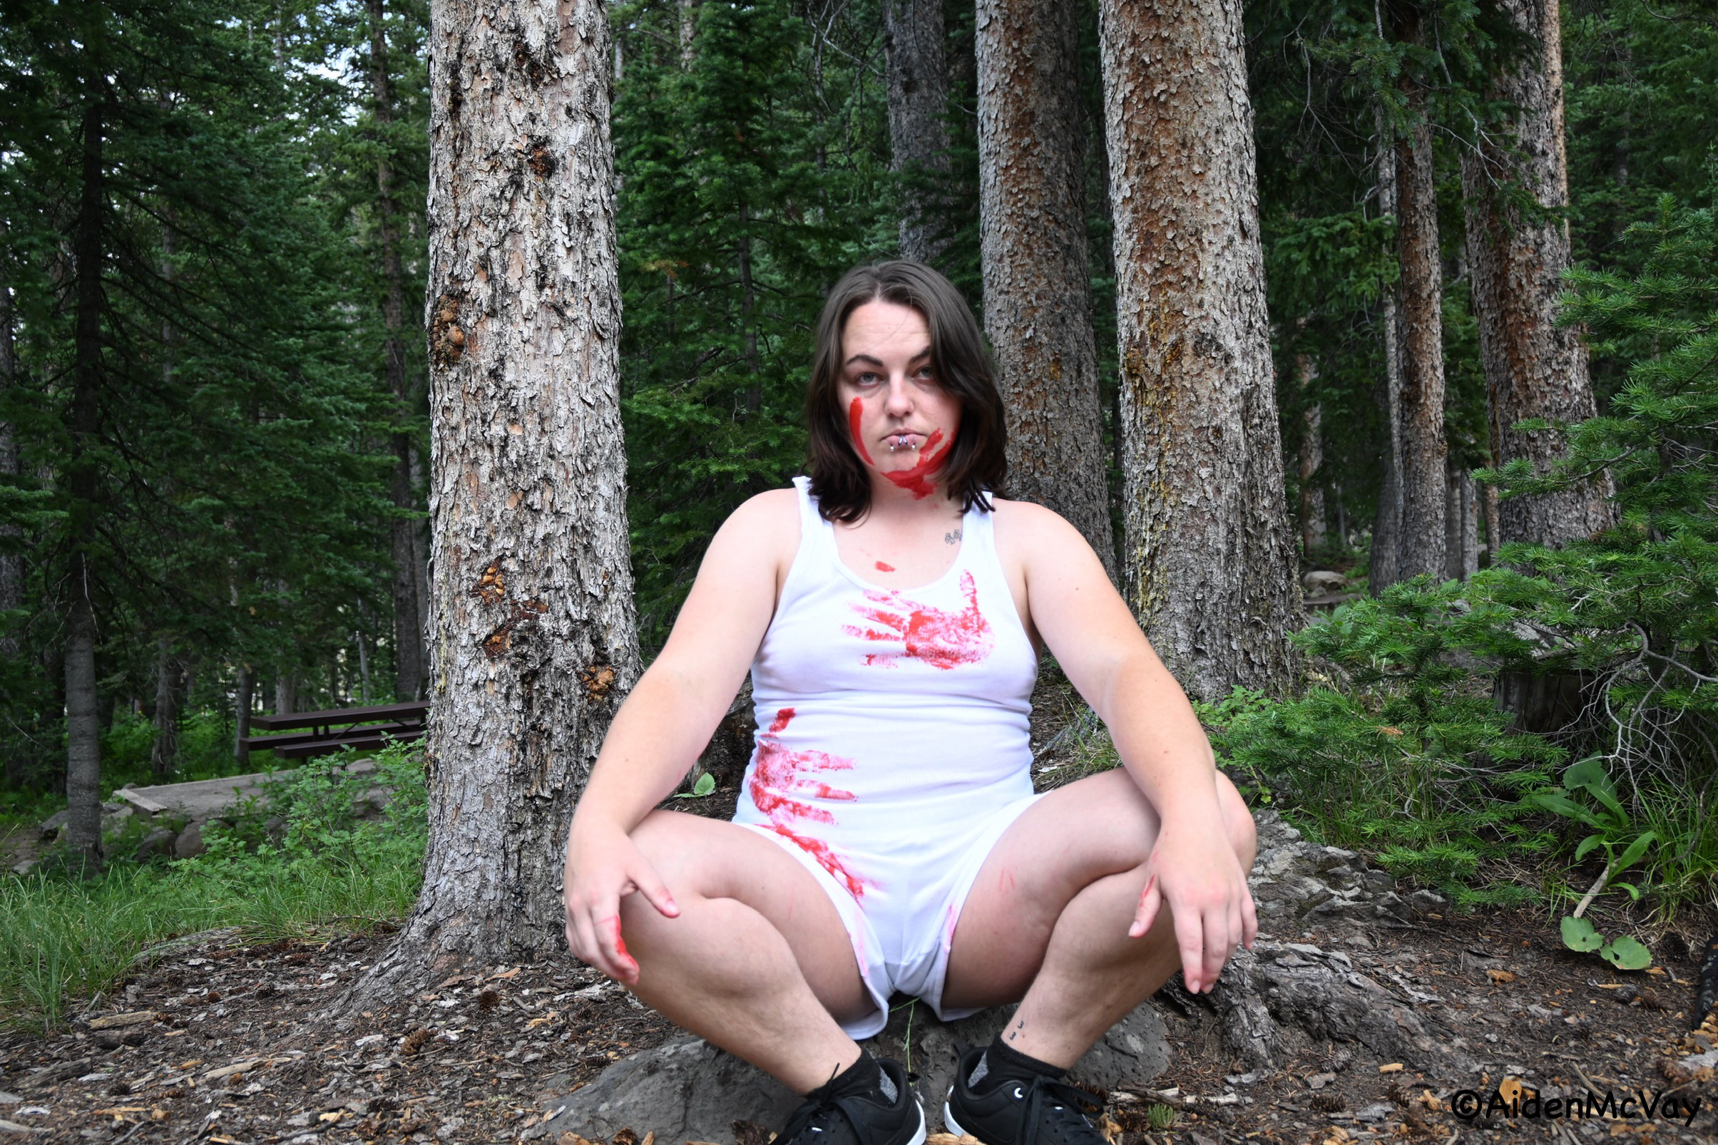Daisy McCarty. We choose the bear photoshoot by Aiden McVay

The social media hypothetical has been asking women, “Would you rather encounter a random man or a random bear in the forest?” And the overwhelming majority of women have chosen the bear.
Although women have numerous reasons why they chose the bear, men consistently comment and berate women for their decision.
Men have left comments such as, “go to the woods then and experience what it’s actually like to be there with a wild bear“, “this whole argument is hilarious”, “they are not choosing the bear: 10 out of 10 women will hide behind a man, should they encounter a real bear.”
More comments by men directed at women include: “Brain dead,” “There’s no way [a] woman would choose a bear over a man,” “A bear would kill you in five minutes without thinking,” and “tbh being scarier than a bear is a flex.”
There are even memes depicting men hugging bears after having “spent a week with a woman” and a woman being killed by the bear after choosing it.
Women have their own reasons for why choosing the bear is preferable than choosing the man. These comments from TikTokers illustrate why women are picking the bear:
“If she’s old enough to pee, she’s old enough for me” (@tickertocker), and “If she bleeds once a month and can have babies, she is not a child” (@️Javier️).
Women are leaving responses from their own sexual assault experiences, such as: “At least the bear wouldn’t invite other bears to join in.” “Bears aren’t what I have nightmares of.” “A bear would not watch and laugh at me while another bear attacked me”, and “if I was attacked by a bear, they’d believe me.”
There are more disturbing ones, such as, “If I survive the bear attack, I won’t have to see the bear at family reunions” and “The worst thing a bear can do is kill me.”
Even with women commenting with their experiences, men still continue to disregard what women say. And rather than listen to what we say, they argue back, “Bears also rape” or “I just can’t stop raping everything in a 50 mile radius.”
Even a male sexual assault survivor totally missed the point.
@milliondollarrenter, aka, “The drizzard of oz” on TikTok, stated he was a sexual assault survivor himself, by a woman, and argued that if you go to a store and no one is afraid of men, and that the average woman will interact with 300 men per day and not be scared. The creator also claims the question itself creates bias against men and likens it to a racist question: “…What do you think Islamic men use more to murder their wives with: guns or knives or rope?”
He even stated that he is “standing up” as an abuse survivor and “standing up against a false claim against the nature of men,” and gives a false statistic that only approximately 1 in 1000 men will commit a crime of this nature.
Not only are his statistics completely false, he ignores women’s comments on his own page about the real fear we face.
However, there are a few content creators that are listening to women. @jon.the.detective, TikTok creator and former police officer of 31 years, 11 of them being in the crimes against persons department said, “… my daughter alone with a man or a bear, me understanding how men will continue to harm women at an alarming rate, I go bear every day of the week.”
But a comment on @jon.the.detective’s video put it into perspective. @Alexysk: “There are two kinds of men: the ones who say “bear,” and the ones who are the reason we say “bear.”’
The origin of this hypothetical scenario started with TikTok creator @callmeBkBk, with him ending a video stating “if you’re alone in the woods, seeing a man is 10 times scarier than seeing a bear” and him making a video in response to a comment saying that seeing a bear is actually scarier than a man. @callmeBKBK responded to that comment with a video describing why women are more scared of men than a bear, and that response went viral, and this hypothetical was created.
The TikTok creator said, “I never presented it as a ‘Would you rather’ question, because I already knew that women were picking the bear and men were picking the man.” He continues in his video, “so my intention was to get men to think about why the world looks so different for women that they would actually choose the bear.” He challenges men to get to a place where they can understand why women choose the bear, and if you did, “congratulations, you’ve experienced one percent of one percent of one percent of what they experience every day of their lives, and you experienced it for 2 1/2 minutes.”
@callmeBKBK also made another video about what girls are taught. He states, “… that they should fight with everything … that it’s better to die on the street then get in that van … that they should use their nails and their teeth so that afterwards there is DNA evidence.” He said in his video that there’s an assumption that all girls are going to have to experience this at some point and to “Use your imagination to put yourself in someone else’s shoes for a little while.”
And if women’s comments and experiences weren’t enough, along with men’s abhorrent rape and murdering comments, there’s TikTok user @dadchats statistics. @dadchats laid out the statistics of the scenario, stating that if you understand the statistics, “The answer is unequivocally a bear.”
In his video, he compares the statistics of bear attacks and women attacked by men, then adjusts the population of bears by a multiplier of 485 to make it proportional to the population of men.
“…you’re still two times more likely to be killed by a man than a bear if you are a woman in the US, and 220 times more likely to be involved in a non-fatal attack by a man than a bear.”
He also mentions that bear attacks are not underreported as they are in sexual assault victims and states “Approximately only 1/5 of violent encounters by men against women are actually reported, and less than 1/5 of those actually lead to an arrest.”
And there is also empirical evidence compiled by the North Coast Rape Crises Team: “An estimated 91% of victims of rape and sexual assault are female and 9% male. Nearly 99% of perpetrators are male.”
“Around the world, at least 1 in 3 women have been beaten, coerced into sex, or otherwise abused in their lifetime. Most often, the abuser is a member of her own family or is her partner.” and “Only 2% of rapists are convicted.”

Tayen McVay, bloody handprints represent non-consensual touch. Photoshoot by Aiden McVay.
(supportingsurvivors.humboldt.edu)
Or from Michael Paymar’s book Violent No More: Helping Men End Domestic Abuse, he estimates that 1 in 4 men will use violence against his partner in his lifetime.
But what is more important than the statistics, or the violations that men have done to corpses, or the 2022 Monitor Lizard rape by four men, is @dadchats second reason that women are choosing the bear: “because women are telling you that it’s the bear.”
The point the men are missing, and even some women, is not just that women are statistically safer with a bear than a man, but the threat of real harm (by men) is something we face every day. And rather than believe us or even statistics, we are put down, told our fear is irrational. And rather than open up a dialogue to see why we are afraid for our lives or confronting the men that are making the comments and making rape jokes, they are dismissing the very thing the man-versus-bear scenario is actually about.
Believe Women.

