Welcome to the House of Romanova!
By Aiden McVay

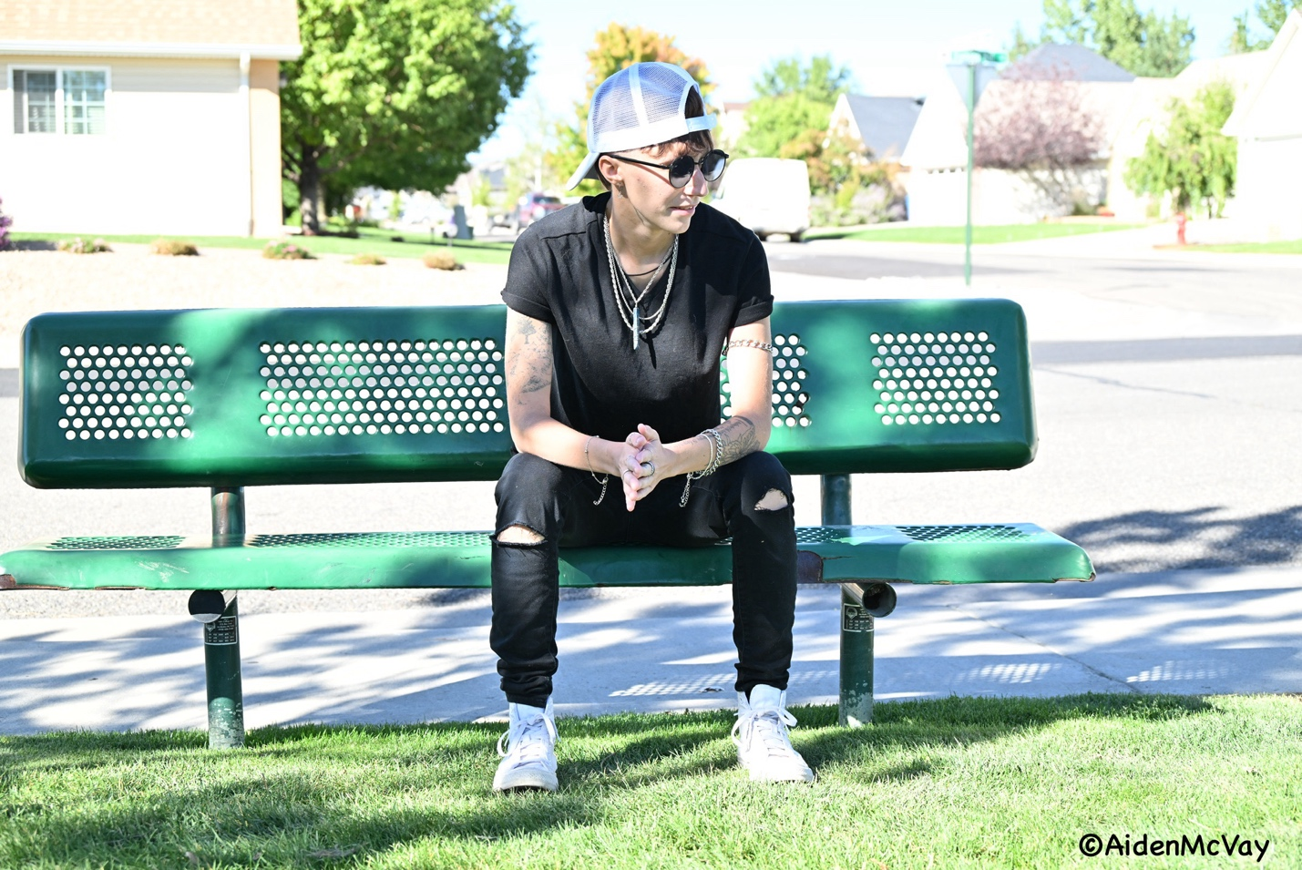
I am so excited to introduce you to Xander Romanova, a.k.a. Craven Moore Romanova and his new drag house! I was able to interview him about The House of Romanova, the inspiration behind it and his plans for the future.

Aiden McVay: What is your name and what are your prounouns?

Craven Moore Romanova: The name that I go by every day is Xander Romanova and my drag name is Craven Moore Romanova. My pronouns are He, him.

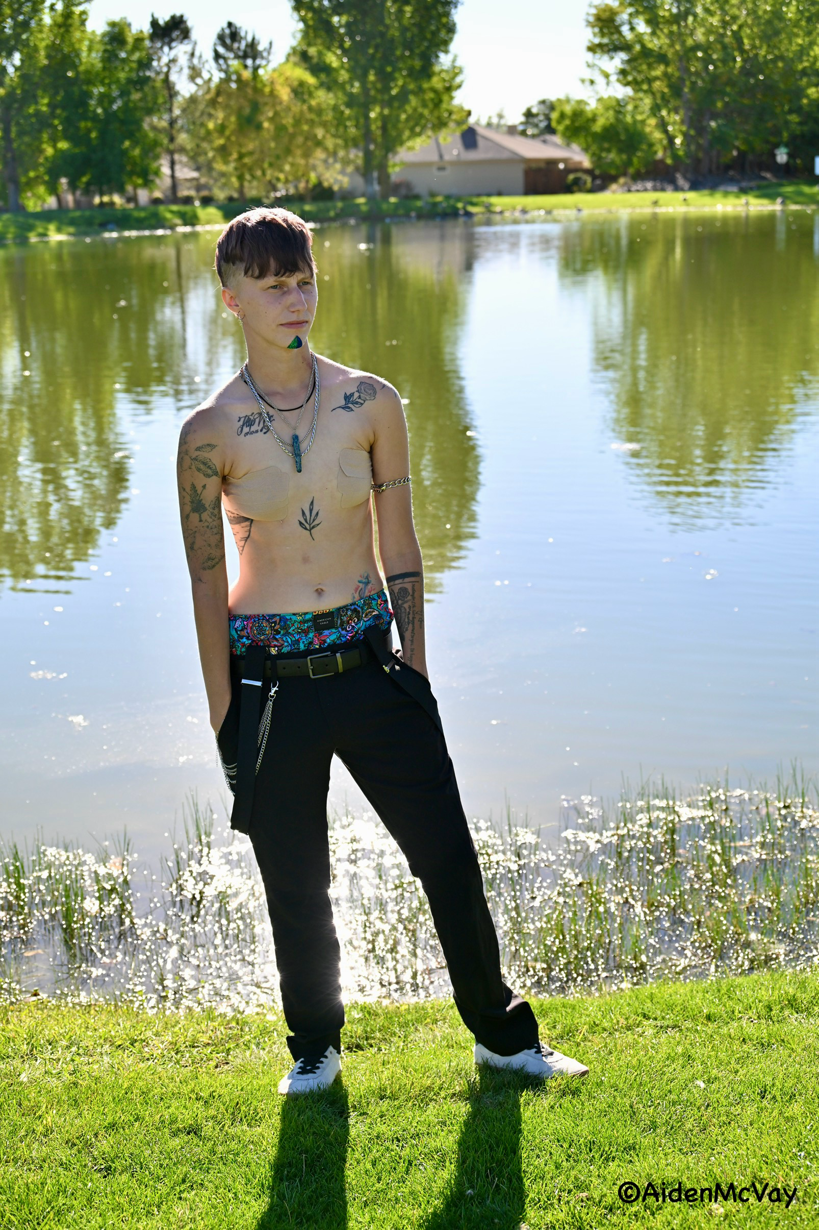

AM: Where were you born?

CR: Moscow, Russia.

AM: When did you move to Colorado?

CR: 2009

AM: How did you get started in drag?

CR: I started going to the local bar here in town, that was Charlie Wellington’s and got my start there with Liz and Stella. And once changed into Good Judy’s , I really started to perform and met the Van Dyke family and they kind of gave me my start. So thank you to them. And they always encourage me to branch out on my own; so I did and created my own house.

AM: When did you start performing?

CR: I started performing about three years ago.

AM: What are your goals for drag and performing?

CR: Just to expand to create my own artistry and take the people that I’ve met along the way with me on the journey.

AM: What are your drag inspiration?

CR: Honestly my parents aren’t very accepting of my lifestyle and I had no outlet for who I was and I had a bunch of unsureness and I’ve always been a musician and I put the two and two together and that was my way of stepping out.

AM: What made you decide to start your own drag house?

CR:Honestly, it’s a little bit of a heartbreak. I got pushed out of the family I was in. I had to rediscover myself and how I wanted to be in drag. Instead of being molded into some thing I didn’t want to be.
So I figured having a drag house that was completely inclusive, non-judgmental, non-conformative, was the way to go. I wanted to create a safe space for myself and others.

AM: When did you decide to open your own drag house?

CR: The idea has been in my head for about four or five months now. But I just recently recently opened the house this past week.

AM: Can anyone join?

CR: Absolutely. Its an open house. We have a few guidelines to collaborate with a performer, but ultimately it is their choice if they want to join. We do allow guest performers if they don’t want to fully join the house. We will support anyone.

AM: Tell me about the house crest. The inspiration? The meaning? The colors?

CR: We always stay classy, professional and stay respectful, so that’s where the skeleton with the mustache is a playoff of that. The House of Romanova is the name and inspiration behind that is my real legal Russian last name so I get that for my birth side of the family. So I wanted to put my past into the future with a man that I am growing into. House colors are kind of like an emerald green and royal blue type fusion.

AM: Where have you performed?

CR: Mostly I perform at good Judy‘s here in Grand Junction, I’ve attended a bunch of Prides, I’ve performed this past year in Ridgeway for Ouray County, and then up here at pride.

AM: Favorite venue that you have performed?

CR: Honestly I haven’t had a favorite venue yet I love all the venues that I’ve gone to.. nothing felt quite special yet, but I think I’m in my own way with that.

AM: Where do you see your future in performing drag?

CR: So I have a lot of confidence when it comes to performing pop songs and the upper beat kind of stuff but personally I am a country boy at heart. That’s how I grew up. Maybe we’ll bring out the cowboy hat here in the future.

AM: What would you like to see happen with your drag house in the future?

CR: To have a giant family atmosphere of performers who love expressing themselves and supporting others. I want not only support for performances but to create a friendship with these performers. I just want us all to dance, have fun, share what we love with a crowd and create art.

AM: What advice would you give someone starting off and drag?

CR: Don’t lose yourself in it. Don’t let it absolutely consume you. Don’t listen to all the other voices of course take the advice. Take the love. Take the criticism. But at the end of the day, it’s your art. And there’s no definition to drag. And don’t let anyone tell you a definition to drag. And allow that Grace to love yourself in every performance. Don’t be too hard on yourself.

I can’t wait to see what Craven Moore and the House of Romanova do next with their welcoming house of inclusivity! If you have any questions about the house or joining contact: https://www.facebook.com/profile.php?id=61565015984489 or https://www.instagram.com/craven.moore.romanova?igsh=MTBudW9xNTFhMGowZA==

