What’s Good at Good Judy’s
Photos and article by Aiden McVay
Good Judy’s isn’t your average bar, it’s a LGBTQ+ friendly bar and club that celebrates diversity, welcomes its patrons, and protects its community.
Owner Jesse Daniels creates an environment that is fun and “where everyone can feel safe, comfortable, and free to express themselves.”
Jesse Daniels bought the club, formally Charlie Dwellington’s, just 13 months ago. Jesse told me that the “… inspiration of Judy’s was to take what Charlie’s have been doing and raise the vibration of that and expand…adding more shows into the LGBTQ community.”
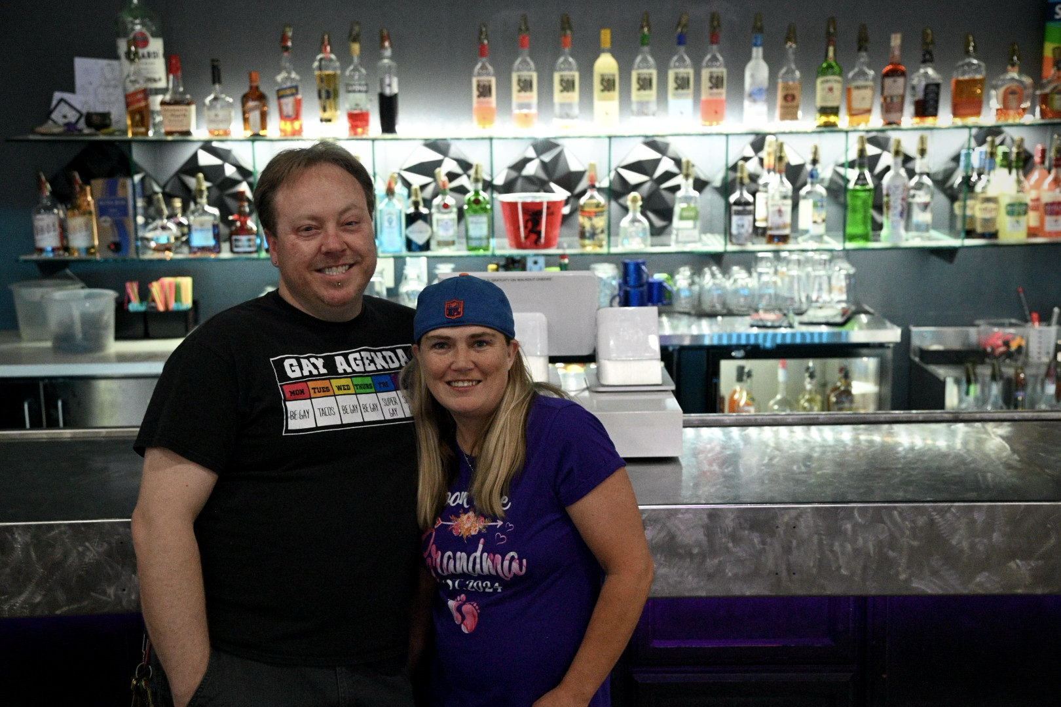
And elevate they did. Even the logo got a drag makeover.
Brooke Safken, (she/her they/them), patron and graphic designer for Good Judy’s Logo and mural, said, “…(it) would be fun to envision “Charlie” transitioned or in drag. The owners and I already decided that a friendly face with a campy feel was going to be part of the logo, so including that bit of locational history was a fun addition to play with! “
The logo isn’t the only friendly face you’ll see there. Leslie Saenz (she/her), performer Madam VanDyke said, “I love it there because I feel like I belong; I really don’t feel that way anywhere else.” Lexi (she/her), longtime patron, said, “It’s very warm and inclusive and I’m treated like family there. The atmosphere is pure love and acceptance of everyone…”
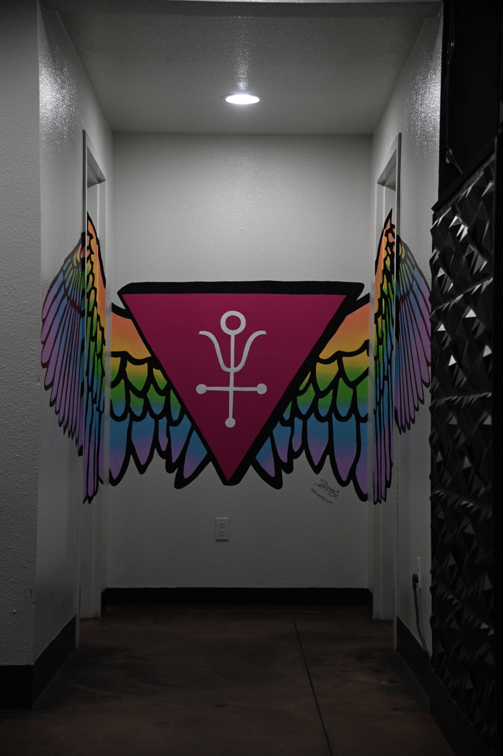
And to make sure that everyone is included, the events at Good Judy‘s are diverse.
They offer a wide variety of events including karaoke, dance parties, drag shows for both long-time and up-and-coming performers and out of town entertainers like Mama Tits, and of course, home to the western slope’s longest running drag show, Second Saturday with Stella Rae Van Dyke. But Stella Rae isn’t just a fantastic host, she is a DJ, MC, and a stunning performer.
Additionally, Stella Rae works with Daniels coming up with and coordinating events. She plans and runs much of the entertainment and advertising and managing the performers.
The patrons get the full experience of club life with a full array of alcoholic and non-alcoholic beverages, welcoming staff, and gorgeous performers. But they don’t see what goes on behind-the-scenes. When asked what the hardest part of running Good Judy’s was, owner Jesse Daniels replied, “Balance-trying to keep up the pace of events and keep up with staff and everyone’s schedules. It’s extremely hectic ordering product and all those things I would say there’s a lot of alot of moving parts. That have to be constantly maintained.”
And Jesse and his staff do a fantastic job of keeping everything running smoothly.
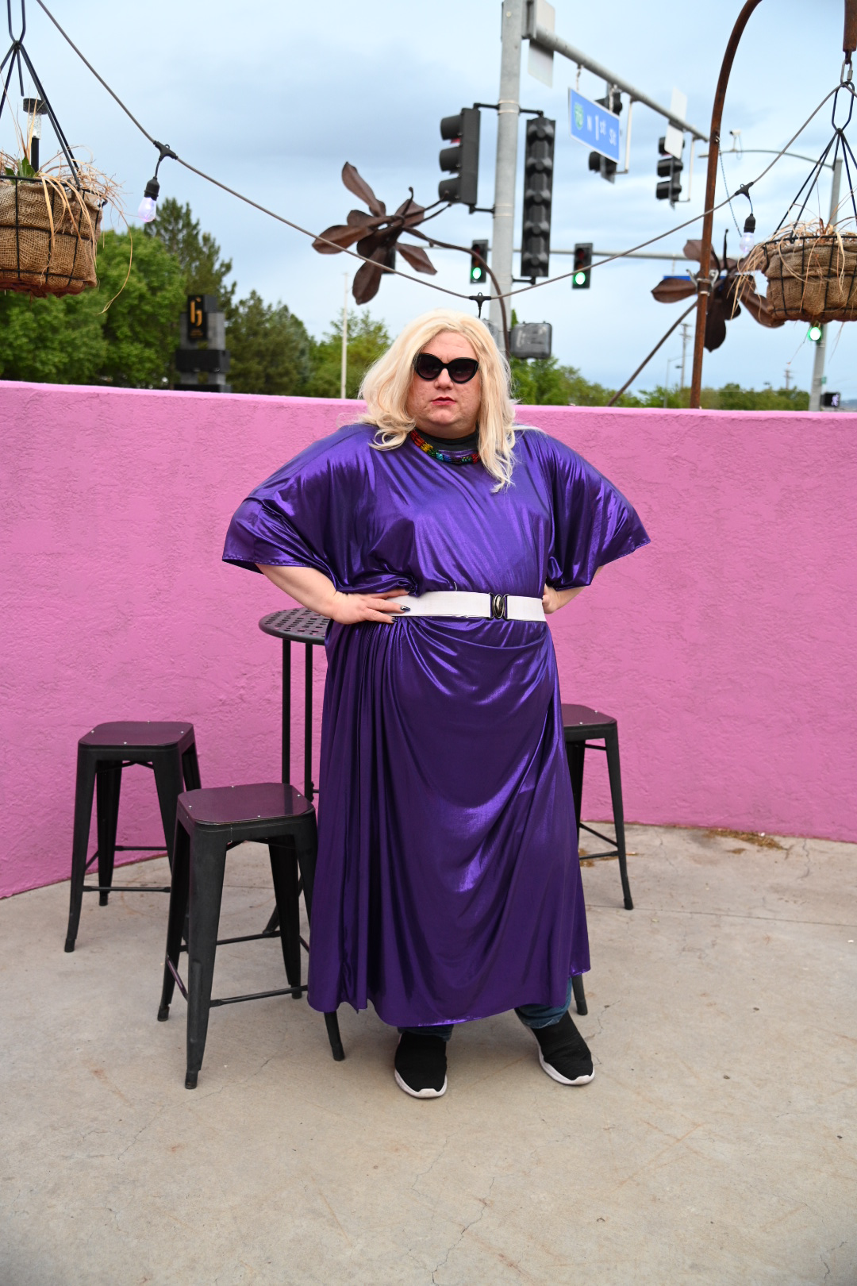
But what makes Good Judy’s unique are the people. “It’s the people who make it what it is.” Lexi said. She continued, “Everyone from Jesse the owner, to the staff, performers, regulars and visitors. Good Judy’s is a place populated by love, where you are accepted no matter how you present, your abilities, your religion, sexual orientation, etc.”
Brooke Safken said, “The atmosphere is completely different and unique…It feels like coming home!” And I completely agree with Stella Rae when she said “Not only is it an authentic queer space, Judy’s features premiere shows, excellent DJ’s, a space you can actually dance in, safety, good service, a clean environment, and seldom any lines. It’s nightlife on your terms.”
Good Judy’s gives the queer community a place to thrive. Jesse Daniels has truly created a space that continues the drag tradition, but that has been updated and elevated for the future of the LGBTQ+ community.
For the most updated events:
https://www.facebook.com/goodjudysgj
https://www.good-judys.com

